SAILING INSTRUCTIONS
1. RULES
1.1 Bartley Sailing Club implements the RYA Racing Charter and sailors are required to undertake to sail in compliance with the Charter, details of which can be found at the front of the RYA Rule Book (Racing Rules of Sailing 2021-2024).
2. NOTICES TO COMPETITORS
2.1 Notices to competitors will be posted on the blackboard located at the OOD hut.
3. CHANGES TO SAILING INSTRUCTIONS
3.1 Any changes to sailing instructions will be posted on the blackboard located at the OOD hut not less than 15 minutes before the start of the race.
4. SIGNALS MADE ASHORE
4.1 Signals made ashore will be displayed on the flag mast at the OOD hut. Signals made afloat will be displayed on a mast on the committee boat.
4.2 Personal buoyancy must be worn by all competitors at all times whilst within the bounds of the reservoir perimeter fencing and whilst afloat. This is a rule of Severn Trent and MUST be complied with. Flag Y will not be displayed. This changes RRS 40.
5. REGISTRATION & EQUIPMENT INSPECTIONS
5.1 Competitors shall complete all registration requirements before racing.
5.2 Equipment shall be class legal to ensure fair racing.
6. SCHEDULE OF RACES
6.1 Registration will take place on-line via the ITCA website prior to the event.
6.2 Briefing will be at 10.30 on the patio outside the clubhouse.
6.3 First race will commence at 11.00
6.4 No warning signal will be made after 16.00
6.5 Prize giving will be in the clubhouse as soon as practical after the completion of the final race.
6.6 There will be 4 races with a target time of 40 minutes for the lead boat.
6.7 There will be 2 races back-to-back in the morning followed by a lunch break and 2 races back-to-back in the afternoon.
7. THE COURSE
7.1 The course and number of laps may be shown on the committee boat using numerals with background colours indicating the side on which mark is to be left (red for port, green for starboard) and displayed in the order in which marks are to be passed. The number of laps will be shown by a numeral on a white background.
8. MARKS
8.1 Course marks are spherical buoys with numbers or letters marked on them. They are numbered from 1 to 8 anticlockwise around the reservoir. There are four additional marks. Mark “0” is located between marks “1” and “8”. Marks “A”, “B” and “C” are located down the centre of the reservoir (“A” being nearer the dam). The location of marks is shown on the course board. The even numbered buoys are orange, odd numbered buoys are blue, A B and C are black and 0 is green. The Race Committee also has the option of using temporary marks. These will be large inflatable yellow cylinders.
9. THE START
9.1 Races will be started using rule 26. The starting sequence will be 5 – 4 – 1 – go
9.2 The Topper Class Flag will be Signal Flag , if this is not available then signal flag “T” will be used.
10. START LINE
10.1 The start line will be between the flagpole on the committee boat and a large yellow inflatable Buoy.
11. FINISH
11.1 The finish line will be between the flagpole on the committee boat and a large yellow inflatable Buoy.
11.2 Flag ‘W’ may be displayed indicating that tail end boats do not need to complete the course but may return to the start area ready for the next race when told to do so by the crew of one of the rescue boats. Finishing positions will be recorded at the time the flag is displayed based on their proximity to the next mark on the course.
12. PROTESTS
12.1 Protests must be made on the appropriate form obtainable from the Race hut and must be returned to the Race hut within 30 minutes of the time the last boat coming ashore either at lunch time for race 1 and 2 or at the end of the day for race 3 and 4. This is the protest limit.
12.2 Boats intending to lodge a protest shall inform the committee or safety boat immediately upon finishing a race.
13. SCORING
13.1 The series scoring used will be the RRS Appendix A - Low Point System.
13.2 The number of races to be scored will be based on the number of races sailed. If up to 3 races are sailed all races will count. If 4 or more races are sailed then there will be a single discard of the race result in which the sailor recorded their lowest position. One race shall constitute a series.
13.3 A boat that did not start, did not finish, retired after starting, or was disqualified shall be scored points for the finishing place one more than the number of boats entered in the regatta.
13.4 All rigs (5.3, 4.2 and 5.3 reefed) shall be scored as a single fleet, with 4.2 Sails being identified by the Race officer to enable Event and 4.2 results.

14 OUTSIDE HELP
Rescue crews are permitted to assist helms who are struggling to right their boat after a capsize. The crew will stand by until it is apparent that assistance is required and then assist in righting the vessel. Helms may then continue to race as the capsize is viewed as sufficient penalty. The rescue crew will attend and assist in the order that they see vessels capsize. This changes RRS 41.
15 DISCLAIMER OF LIABILITY
15.1 Competitors participate in the regatta entirely at their own risk. See RRS Part 1 section 3, Decision to Race. The organizing authority will not accept any Liability for material damage or personal injury or death sustained in conjunction with or prior to, during, or after the race or regatta.
15.2 Sailing is by its nature an unpredictable sport and therefore inherently involves an element of risk.
15.3 By taking part in the event, each competitor agrees and acknowledges that:
a) They are aware of the inherent element of risk involved in the sport and accept responsibility for the exposure of themselves, their crew and their boat to such inherent risk whilst taking part in the event;
b) They are responsible for the safety of themselves, their crew, their boat and their property whether afloat or ashore;
c) They accept responsibility for any injury, damage or loss to the extent caused by their own actions or omissions;
d) Their boat is in good order, equipped to sail in the event and they are fit to participate;
e) The provision of a race management team, safety boats and other officials and volunteers by the event organiser does not relieve them of their own responsibilities;
f) The provision of safety boat cover is limited to such assistance, particularly in extreme weather conditions, as can be practically provided in the circumstances;
g) Their boat is adequately insured, with cover of at least £3,000,000 against third party claims;
Neither this document nor any inspection of the boat limits or reduces the absolute responsibility of the owner/person in charge for the crew, the boat and her management.
15.4 Nothing done by the organisers can reduce the responsibility of the boat, nor will it make the organisers responsible for any loss, damage, death or personal injury, however it may have occurred, as a result of the boat taking part in the racing. The organisers encompass everyone helping to run the race and the event, and include the organising authority, the Race Committee, the Race Officer, patrol boats and beach masters. The provision of patrol boats does not relieve the boat of her responsibilities.
16 COACHING
ITCA (Topper Class Association) may arrange for a coach to be provided for on-water coaching to the less experienced sailors during the races. This is not intended to give individuals unfair advantage, rather to support their development and motivation for the future. The coach will adhere to coaching principles and behaviours as required under Rule 2, Fair Sailing. No other on-water coaches are permitted for the duration of the event

17 HAZARDS
There are 2 specific hazards with small yellow buoys marking their position, one is by the dam between 8 and A denoting cables that may foul foils, the other is between 0 and the shore denoting a concrete stack 1m below the surface.
The areas shown in blue on the diagram below contain lines of Barley Straw in nets semi-submerged and marked with small floats. These are an obstruction and room may be called to tack.
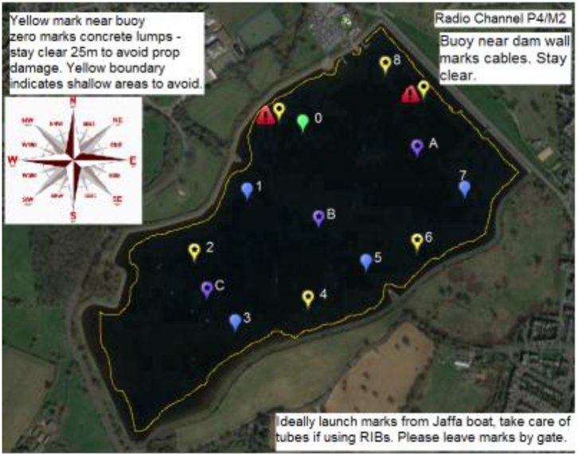

Diagram of Mark positions / colours for competitors
