SE TOPPER Open Meeting
Hosted by Crawley Mariners YC
Sunday 21st April 2019

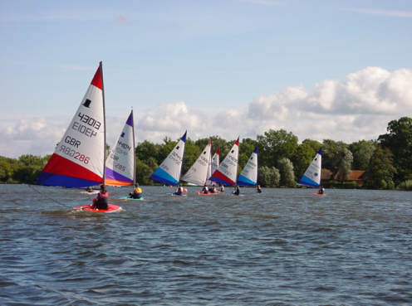
Gates open at 08.15
Briefing 10.00 & First Race 11.00
Entry Fee £10
There will be prizes for the main winners, plus additional prizes for those just starting out and/or endeavour. We aim to run 2 races, followed by lunch and 2 races after lunch, subject to wind conditions.

Hedgecourt Lake is quite protected and therefore an ideal venue for those new to Open Meetings. However, due to its restricted size we have to limit numbers to 35. So, if you do intend to come, you are permitted to take part in this Open at your own club without being a member of ITCA, but if you decide you want to do others you will need to join. It is not expensive and you will get lots of help and of information.

Go on, dig out that Topper and come along!

Dogs on leads are very welcome

Refreshments & Snacks at a reasonable cost during the day
Bacon butties as sailors arrive
Hot Lunch with to order - cakes or fruit

LUNCH: Do let us know if you will want lunch on: training.cmyc@gmail.com

