Stewartby Water Sports Club- Sailing Section: Sailing lnstructions for Open Meetings
1 Rules:
1.1. The regatta will be governed by the rules as defined in The Racing Rules of Sailing (RRS), and the
prescriptions of the RYA.
1.2. The class rules, as applicable to the class or classes described in the Notice of Race will apply.
1.3. Competitors should note that the Sailing Section of Stewartby Water Sports Club implements the RYA Racing
Charter and that they will be required to undertake to sail in compliance with the Charter, which can be found at the front of the RYA rule book (Racing Rules of Sailing) 2017-2020.

2 Notices to competitors:
2.7. Notices to competitors will be posted on the official notice board in the clubhouse.

3 Changes to Sailing lnstructions:
3.1. Any change to the sailing instructions will be posted before 10.00 am on the day of the regatta.

4 Signals made ashore:
4.1. Signals made ashore will be displayed at the flagstaff located behind the race control building.
4.2. When a RED flag is displayed ashore the lake is closed and sailing is not permitted. Attention may be drawn
to the flag by repeated sound signals. Boats afloat must return to shore as soon as possible.
4.3. When the code 'H' signal is displayed ashore the support boats are unavailable or withdrawn from use and
safety cover shall be suspended until the signal is removed. Races not started may be postponed.

5 Schedule of races:
5.1. A briefing to all competitors will be held in the clubhouse at 10.15am.
5.2. The schedule of races shall be stated at the briefing.
5.3. The open meeting will consist of the number of races specified in the Notice of Race.
5.4. The scheduled time for the warning signal for the first race will be stated in the Notice of Race for the regatta.
5.5 To alert boats that a race or sequence of races will begin soon, the orange starting line flag will be displayed on the race committee signal vessel with multiple sound signals not less than one minute before a warning signal is made.
6 Class Flag:
6.1 The class flag[s] will be stated at the briefing.

7 Courses:
7.1. No later than the warning signal, the course to be sailed shall be displayed with coloured numbers from the
committee boat or ashore on the official notice board adjacent to the race control building. Details will be given at the briefing.

8 Marks:
8.1. Marks used for racing may include:
(a) White or orange spherical buoys fitted with numbered, lettered or coloured flags
(b) Large inflatable orange buoys
(c) The port end starting mark will be an orange dan buoy with an orange flag.
8.2. The approximate location of the spherical buoys is shown in the accompanying map. The Race committee may move buoys to set courses.

9 Areas that are obstructions:
9.1. The racing area is bounded on the eastern and northern sides by white dividing line buoys. Boats may only
cross this line in the event of an emergency.
9.2. An imaginary line joining each dividing-line buoy ranks as an obstruction to sea-room.
9.3 lf the racing area is to be extended this will be made clear at the briefing.

10 The Start:
10.1 Races will be started using a 3 - 2 – 1 - GO sequence. This changes RRS26.
10.2 The starting line will be from an orange pole displaying an orange flag on the committee boat and the port
end starting mark.
10.3 A boat starting later than 3 minutes after her starting signal will be scored DNS without a hearing. This
changes RRS 44 and A5.
10.4 Boats whose warning signal has not been made shall avoid the starting area.

11 The Finish:
11.1. The finish line shall be between the orange pole on the committee boat and the port end starting mark.
11.2 ln addition to the procedure for shortening course in rule 32, the race committee may also award a finishing
score to a boat that is still racing by displaying to her from a committee vessel (which may be in motion) flag
W with one sound signal. A boat so notified is no longer required to sail the course (changing rule 28.1), shall
stop racing and shall return to the starting area, or return ashore if there is no more racing. A finishing score
under this sailing instruction will be the score she would have received had she sailed the course and finished
within any time limit, without gaining or losing any place. However, when two or more boats that are
overlapped are notified, they will be scored as if they were tied. The decision by the race committee to use
this procedure or not to use it shall not be grounds for requesting redress, changing rule 60.1(b).

12 Time limits:
12.1 Boats failing to finish within 30 minutes after the first boat sails the course and finishes will be scored Did
Not Finish. This changes Rule 35 and 44

13 Protests and requests for redress:
13.1. Protest forms are available at the Race Office in the clubhouse. Protests shall be delivered there within the protest time limit.
13.2. For each class, the protest time limit is 30 minutes after the last boat in the fleet has finished the last race of
the day. The same time limit applies to protests by the race committee about incidents they observe in the
racing area and to request redress.
13.3. Protests will be heard as soon as possible. The schedule will be posted on the official noticeboard at the
close of the protest time limit.
13.4. The protestor and those protested will be informed of the time and place of the hearing.
13.5. The protestor and those protested should ensure that the relevant persons, including witnesses are notified
and available at the time and place stated.

14 Series Scores:
14.1 The Low Scoring System (RRS Appendix A) will apply.
14.2 One race is required to be completed to constitute a regatta.
14.3
(a) When fewer than 4 races have been completed, a boat’s series score will be the total of her race scores.
(b) When 4 or more races have been completed, a boat’s series score will be the total of her race scores excluding her worst score

15 Safety:
15.1. Adequate personal buoyancy for crew members shall be worn whilst afloat and failure to do so will result in immediate disqualification. Wetsuits and dry-suits do not constitute adequate personal buoyancy.

16 Equipment checks and measurement:
16.1. A boat or equipment may be inspected at any time for compliance with the class rules and sailing instructions.
16.2. Each boat shall produce on demand a valid measurement certificate with a current buoyancy endorsement.

17 Radio communication:
17.1. A boat shall neither make nor receive radio transmissions while racing. This restriction also applies to mobile phones.
18 Prizes:
18.1. Prizes will be given to First, Second and Third places, and other places depending on the number of entries.
18.2. Other categories may be decided at the discretion of the Race Committee and subject to the entries received.

19 Disclaimer of liability:
19.1 Competitors participate in the open meeting entirely at their own risk. See Racing Rules of Sailing, Rule 4, Decision to Race. The organizing authority will not accept any liability for material damage or personal injury or death sustained in conjunction with or prior to, during, or after the regatta.
19.2 Competitors are entirely responsible for their own safety, whether afloat or ashore, and nothing reduces this responsibility. lt is for competitors to decide whether their boat and its helm (and crew) are fit to sail in the conditions that they might find. By launching or going to sea competitors confirm their boat is fit for those conditions and that they are competent to sail and compete in them. Nothing done by the organizers can reduce the responsibility of the owners and/or competitors, nor will it make the organizers responsible for any loss, damage, death or personal injury, however it may have occurred, as a result of the boat taking part in the racing. The organizers encompass everyone helping to run the event and include the organizing authority, race committee, race officer, safety officer, support boat personnel and beach masters. The provision of safety boats does not relieve owners and competitors of their responsibilities.

20 lnsurance:
20.1 Each participating boat shall be insured with valid third-party liability insurance with a minimum cover of £3,000,000 per event or equivalent.
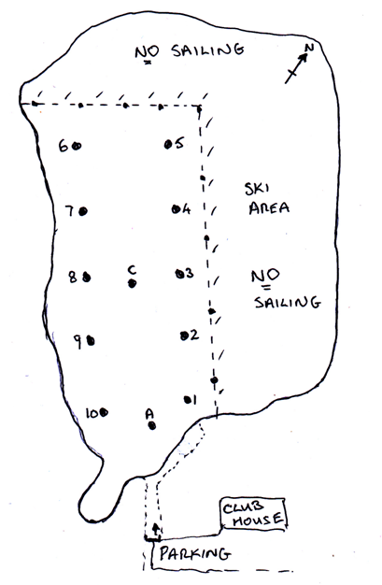

STEWARTBY LAKE SAILING AREA

