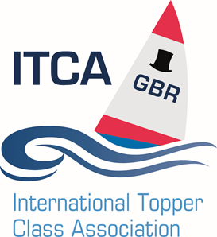

Notice of Winter Training.

Southern Area

Supported by

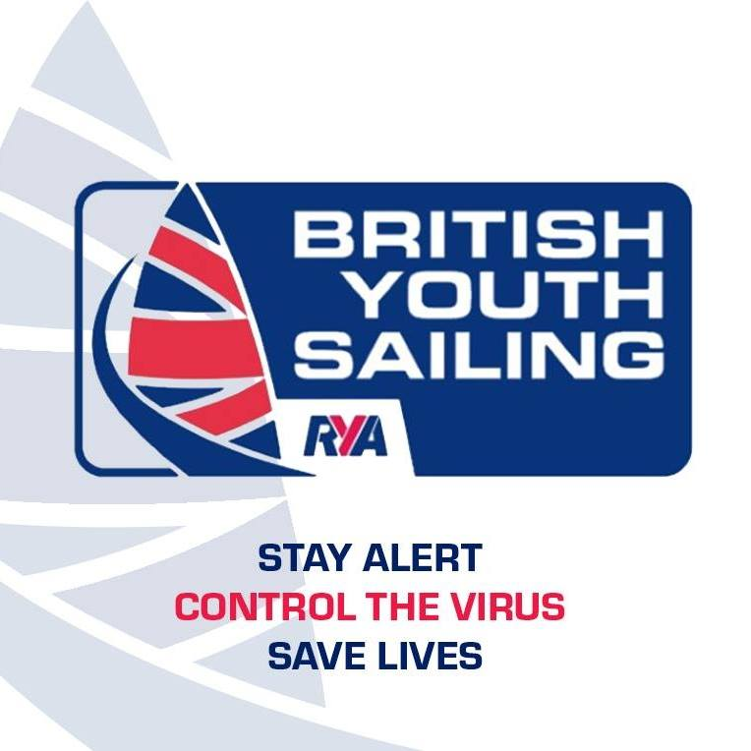

Version 1.0

Published 21st October 2020

The purpose of this Notice of Training is to confirm the generic arrangements for the ITCA (GBR) Southern Area training held at various locations during 2020/21 Winter season.

Overview
The training will generally take place on weekends generally on Saturdays.
- The training is open to any sailor who has completed a beginners sailing course (e.g RYA stage 2)
- Sailors will use their own Toppers
- It will be expected that all sailors can prepare and launch their boats and sail in all directions in light and medium winds, including tacking and gybing.
- Either a 5.3 or a 4.2 sail can be used
- More advanced sailors are welcome to sign up, in which case sailors may be set into training groups for on the water exercises.
- The cost of a days training will be £40. Meals and accommodation are not included.

Head Coach
The Head Coach will oversee and run all aspects of the training camps, contacted details will be confirmed prior to each session.

COVID-19 Considerations

By taking part in any the training covered by this notice, each competitor agrees and acknowledges that they are responsible for complying with any regulations and RYA guidance in force from time to time in respect of COVID-19 and for complying with the [venue/OA/sailing club] COVID-19 procedures. Competitors and support persons shall comply with any reasonable request from an official. Failure to comply may be misconduct.
Club may cancel the event at short notice, as a result of Government action or to comply with the latest regulations or local lockdown. The Club or the class associations will not accept any responsibility for any costs incurred by competitors, friends, families or support teams making arrangements to attend the training.
The overriding principle remains that individuals attending the host Club to sail do so entirely at their own risk and responsibility. Visitors and members are required to keep current government guidance on social distancing in mind while attending training. In particular if assisting other members to launch or recover boats using the slipway, please keep a safe distance from each other. Sailors should arrive at the venue changed for sailing. It is unlikely that changing rooms will be open. You may are required to sign into the venue. Social distancing applies at all times. Where, 2m or 1m plus distancing is not practicable face coverings are recommended within buildings.
Sailors and their parent or guardian shall be deemed to have considered their own risk from COVID-19. If any sailor and or their household consider themselves an ‘at risk’ person or persons as detailed by Government guidelines then they must not participate.
Competitors and members of their household showing symptoms or believe that they have been exposed to COVID-19 prior to the commencement of the event should not attend and a refund as detailed in 3.5.1 will be made.
Competitors must accept that although the Class Association and host will endeavour to reduce the risk of exposure to Covid-19 this cannot be removed
Details

- Venues

Event | Date | Location
ITCA South Winter Coaching 1 | 25/10/2020 | Rockley Point - Rockley Road, Poole BH15 4RW
ITCA South Winter Coaching 2 | 07/11/2020 | Rockley Point - Rockley Road, Poole BH15 4RW
ITCA South Winter Coaching 3 | 28/11/2020 | Spinnaker Sailing Club - Ivy Ln, Ringwood BH24 3LY
ITCA South Winter Coaching 4 | 05/12/2020 | Rockley Point - Rockley Road, Poole BH15 4RW
ITCA South Winter Coaching 5 | 05/12/2020 | Spinnaker Sailing Club - Ivy Ln, Ringwood BH24 3LY
ITCA South Winter Coaching TBC | 09/01/2021 | Spinnaker Sailing Club - Ivy Ln, Ringwood BH24 3LY
ITCA South Winter Coaching TBC | 06/03/2021 | Spinnaker Sailing Club - Ivy Ln, Ringwood BH24 3LY
Other training events will be planned during this period.
- Entry
  - Pre entry is required using the on-line entry system at www.itca-gbr.co.uk.
  - The entry fee is £40
  - In all cases, the number of entries will be limited by the availability of coaches and safety boats. Once the initial entry limit has been reached, a waiting list will be maintained pending availability of additional places
  - Covid-19 refunds –
    - If a competitor needs to cancel due to a requirement to self-isolate or
    - If due to tighter Government Covid-19 restrictions or adverse weather conditions, the event is cancelled then it will be planned to provide a full refund (however this may be less any unrecoverable costs of the Organising Authority).
  - If an entry is cancelled by the participants for any other reason their entry fee will be refunded as follows:
          - Cancellation more than 14 days before the event. Entry fee less £5 admin charge
          - Cancellation more than 7-14 days before the event if place can be resold. Entry fee less £5 admin charge
          - Cancellation within 7 days of the event. No refunds
  - Any sailor who is unwell should not attend a training camp; to do so compromises the sailor’s recovery or can compromise the health of other sailors. In such circumstances, please contact Andrew Goodman at arearep.southern@itca-gbr.co.uk, in advance.

- Camp Timings: Final detailed plans for the weekend will be provided prior to the camp. Outlined below are the normal timings:
  - The Saturday’s coaching programme will not start before 09:00 on Saturday morning. Plan to be rigged but not changed by then.
  - The training camp will normally be finished by 17:00hrs on Saturday afternoon

- Equipment and Clothing: You need to make sure you bring the following to all training camps:
  - A reliable boat and suitable sailing gear for the conditions.
  - Tracksuit or suitable kit for warm up runs and games.
  - Suitable running trainers for exercising (not fashion trainers!).
  - Notepad and pen.
  - Water bottle and energy bars.

- Parent/guardian support. ITCA (GBR) Training Camps cannot run without parental/guardian support. For training events the following will required:
  - All sailors should have a parent on shore for the duration of the training. Where this is not possible a responsible adult acting “in loco parentis” must be clearly identified and the head coach/shore parent advised
  - At least one “shore parent” each day to remain at the club and to keep in contact with the coaches on the water
  - Rib assistants to go out on the water with the coaches. Typically one for every 6-8 sailors.

- Weather: It is not our policy to cancel camps unless it is unsafe to travel. In the unlikely event that we do need to cancel a camp, we will aim to send an email before 13:00 on the day before the camp is due to commence and will endeavor to post a notice on the ITCA website. Whilst every effort will be made to rearrange a cancelled camp it cannot be guaranteed. Unfortunately no refund will be available if it is necessary to cancel in the interest of sailors safety or if you are unable to attend the rescheduled date.

- Risk Statement. Sailing is by its nature an unpredictable sport and therefore inherently involves an element of risk. By taking part in the training, participants (and their parent(s) or guardian(s) in the case of a participants under 18 years of age) agree and acknowledges that:
  - They are aware of the inherent element of risk involved in the sport and accept responsibility for the exposure of themselves, their crew and their boat to such inherent risk whilst taking part in the event;
  - They are responsible for the safety of themselves, their crew, their boat and their other property whether afloat or ashore;
  - They accept responsibility for any injury, damage or loss to the extent caused by their own actions or omission;
  - Their boat is in good order, equipped to sail in the event and they are fit to participate;
  - The provision of patrol boat cover is limited to such assistance, particularly in extreme weather conditions, as can be practically provided in the circumstances;
  - It is their responsibility to familiarise themselves with any risks specific to this venue and to attend any briefing held for this event.

- Insurance. Each participating boat shall be insured with valid third-party liability insurance with a minimum cover of £ 3,000,000 per incident or equivalent. [DP]

- Media Rights. We may arrange for photographs or videos to be taken of dinghy activities or using event facilities and published on the ITCA or Club’s website or social media channels to promote ITCA or the Club. If you do ‘not’ consent to your / your sailor’s image being used by the Club in this way, please advise us at registration.
- Further Information. For further information please contact Andrew Goodman at arearep.southern@itca-gbr.co.uk

