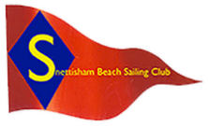Snettisham Beach Sailing Club
ITCA Eastern Area Championships 2023

Notice of Race
10th / 11th June 2023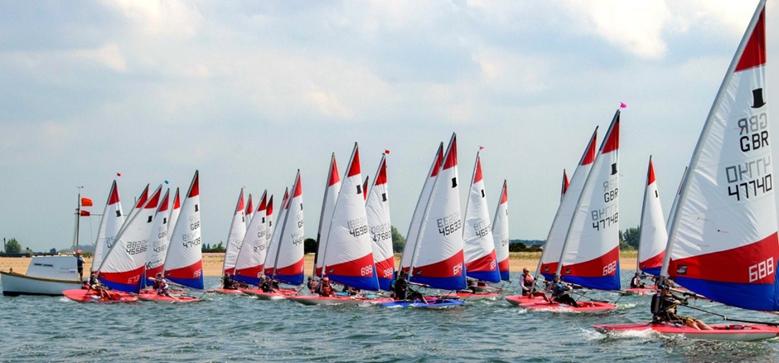
Introduction
Snettisham Beach Sailing Club are delighted to have been Invited by the ITCA to host the ITCA Eastern Area Topper Championship 2023. This event is intended and designed to be the Premier ITCA Topper event for the Eastern Region. Our sea-based club, it is hoped will live up to the challenge.
Rules & Information
- Organising Authority
- The organising authority will be Snettisham Beach Sailing Club
- The event will be governed by the rules as defined in the :- “Racing Rules of Sailing 2020 – 2024”

- Eligibility
  - The event is open to Topper Class Dinghies only.
  - Visiting sailors will be required to be paid-up members of the ITCA. SBSC Home sailors will be permitted to race in this event as their home club.
  - Sailors may choose to use either a 4.2 or a 5.3 sail. Sailors will not be permitted to change sail size during this event.
- Entry

  - Competitors will be required to formally enter the event before taking to the water. This includes full completion of the official entry procedure, including payment of the entry fee.
  - Competitors under 18 will require a signature from a parent, legal guardian or person acting in Loco parentis. Both Sailor and Legal Guardian / Loco Parentis ( if Sailor under 18 years) will be the responsible person for that child and will be required to sign in at the start of the event, during attendance registration.
  - The entry fee will be £30 per boat entered, before Sunday evening 04/06/23 23:59hrs, and £35 after this date, late entries accepted at the discretion of the organisers.
  - Entry will be capped at 40 boats. Additional places may be made available if suitable Safety cover can be arranged. Additional spaces above 40 boats, will not be guaranteed.
  - Entries will be made on-line. By visiting the ITCA GBR website Calendar and following the instructions posted under the Easter Region Topper Championships :-
https://gbrtopper.ourclubadmin.com/event.php?event=1270

  - SBSC may accept late entries at the discretion of the Race officer and SBSC organisers.

- Registration
  - SBSC require all sailors to sign in on reaching the club, as present and ready to race. Registration will be located in the Clubhouse on the morning of the first day of the event.
  - SBSC will be running a Tally system. Sailors are required to comply with this system, by following the Tally instructions and tallying on and off the water each day, to allow the event to run safely and smoothly. Failure to Tally correctly will result in a points penalty.

- Event Schedule
 | Detail
Championship Entry | Online before Thursday 04/06/23 23:59hrs, Late entries maybe accepted at the discretion of Snettisham Beach Sailing Club organisers.
Registration on the day | At SBSC from 10th June 08:00hrs onwards
Competitors Briefing | Online Briefing taking place at a time to be published between 05/06/23 and 08/06/23  This briefing will be recorded and made available on the Topper racing in the East and the Event WhatsApp group shown in this NOR
Welcome Briefing | 09:30 on Saturday - SBSC Veranda
High Water (Kings Lynn) | 11:43 Saturday
 | 12:53 Sunday
Launch Time Day 1 | 09:50 or soon after, when D flag is flown
1st Warning Signal Day 1 | 10:15
Subsequent Starts | Back-to-Back – Up-to 3 Races per day
1st Warning Signal Day 2 | 11:00 or soon after, when D Flag is flown
Last Race Warning Signal – Day 2 | No later than 14:15hrs

- Safety and Sailor preparation
Competitors are required to wear a well-fitting Buoyancy aid in good condition and rated to a minimum 50N floatation capacity.
Competitors should expect, and be prepared to be on the water for up to 4hrs each day. Preparations include plenty of drinking water, snacks on-board and Sailing attire suited to the expected conditions and time expected on the water. Expect the sea-based venue to be significantly cooler than the land in most conditions. Hats and Sun cream strongly advised.

- Sailing Instructions
The Sailing Instructions will be posted on the:-
- Snettisham Beach Sailing Club website www.snetbeach.co.uk
- ITCA Website calendar https://gbrtopper.ourclubadmin.com/event.php?event=1270
prior to the event, and will be displayed on the Official Noticeboard at the event. Sailors are expected to read and understand the SI`s to the best of their ability, prior to arrival at SBSC. The Briefing on the day, will indeed be brief.
It is our intention to run a full Trapezoid course based approximately on the official 2023 ITCA NS event Course cards, in an attempt to make this a great learning and practice event for those who require the learnings in preparation for the larger ITCA events, whilst also aimed at the seasoned NS event racer. This arrangement may change if conditions dictate on the day. Confirmation of course to be sailed will be posted on the official noticeboard on the morning of the event, details confirmed during the briefings.
- Scoring
The event will follow RRS Appendix A scoring system. Competitors highest scoring result, discarded according to the prescriptions in the RRS, if more than 3 races are sailed.

- Insurance
Each participating boat shall be required to be insured with a valid, Current Third – Party Liability insurance cover, with a minimum cover of £3,000,000 per incident or equivalent. By entering this event, you are confirming that the sailor and the boat has adequate insurance arrangements are in place during the entirety of the event.

- Communications
The Official Noticeboard will be located inside the SBSC Conservatory. This Noticeboard should be regarded as the only source of official information for this event.

In addition, we will set up an unofficial WHATSAPP group :- ITCA Eastern Area Champs 2023. Please use the QR code below to access this group.
This group will carry advisory information only, and does not constitute any kind of official Noticeboard, and is intended for general information and Communications about the event only.

- Catering
Club catering arrangements will be publicised on the club website, alongside the SI`s closer to the event. SBSC does not presently operate a permanent Galley, so provision of food is likely to be basic. SBSC is planning to arrange a food event for the Saturday evening. More details to follow.
BBQ`s and Camp cooking is permitted on SBSC property. You are required to ensure all heat sources are safely extinguished promptly, before leaving the cooking area.
- Prizes
  - Prize giving as soon as practical after the last race, on Sunday afternoon.
  - A selection of Spot Prizes will be presented during the Prize giving event. Names of recipients of these prizes, will be drawn from a hat containing all Sail numbers of Sailors competing.

- Photography
By entering this event, competitors and their supporters accept that they may be photographed and/or videoed, whilst participating in the event, and they consent to the taking and use of such images in any media, that may be reasonably expected.
- Accommodation
IMPORTANT NOTICE REGARDING TENTS & MOTORHOMES
Limited Camping is permitted in designated areas in the dinghy park, as are Camper vans. Spaces can only be guaranteed following prior booking and the receipt of confirmation from the designated controller at :- juniorconvenor.snett@gmail.com Spaces allocated on first come first served basis for Pre-booked pitchs. We have no electrical hook-ups and in fact, no mains electricity supply, apart from a club based generator.
Diglea Caravan Park, Snettisham
- https://www.digleacaravanpark.com/index.php

- Glamping / Campervan / Tents – 1 mile from SBSC

Rose & Crown Public House, Snettisham

- info@roseandcrownsnettisham.co.uk

- Very nice, award winning pub in the Village – 3 miles from Sailing Club

Nearest Budget Hotels – Kings Lynn ~ 10 miles

- Further Event Information
Contacts :- Nathan Franklin – juniorconvenor.snett@gmail.com
John Eaton – 07713313588
Mark Turner – 07908636210
Website :- www.snetbeach.co.uk
Event Address :-
Snettisham Beach Sailing Club,
The Beach,
Snettisham,
Norfolk, PE317RB.
