Shoreham Sailing Club ITCA TOPPER 11th June 2022
SAILING INSTRUCTIONS

- RULES
  - The regatta will be governed by the rules as defined in the current ISAF Racing Rules of Sailing, RYA prescriptions and the relevant Class rules. In the case of conflict between the rules and these sailing instructions, these sailing instructions shall prevail.

- NOTICES TO COMPETITORS
  - Notices to competitors will be posted on the official notice board located outside of the clubhouse.

- CHANGES TO SAILING INSTRUCTIONS
  - Any change to the sailing instructions will be posted at least 60 minutes before the advertised starting time of the race or races concerned.
  - Any change to the schedule of races will be posted by 20.00 on the day before it will take effect.

- SIGNALS MADE ASHORE
  - Flag signals made ashore will be displayed on the flagpole near the launching ramp.
  - When the postponement flag (AP) is displayed ashore, '1 minute' is replaced with 'not less than 45 minutes' in the race signal AP (changes rule Race Signals 'AP'].
  - Boats shall not go afloat until flag D is displayed ashore with one sound signal.

- SCHEDULE OF EVENTS
  - The schedule of events shall be as described in the Notice of Race
  - When there are two or more races to be sailed on one day, the warning signal for the second and any succeeding race will be made as soon as possible after the finish of the previous race.

- CLASS FLAG
  - Unless otherwise specified, the warning signal for the class scheduled in the Programme to start first shall be the T flag.

- RACING AREAS
  - The racing area will normally be to the West of the Harbour entrance.

- COURSES
  - The courses are designated by letter (A, B, C etc). Schematic layouts are in Appendix 1 and show the approximate angles between legs, the order in which marks are to be passed, and the side on which each mark is be left.
  - The Committee Boat will display the course to be sailed (by letter) and number of laps on the starboard side prior to the warning signal.
  - When sailing from Mark 3 to Mark 1, boats must sail through the start/finish line. When sailing from Marks 1 and 1a to Mark 3, boats may, but do not have to sail through the start/finish line.

- MARKS
  - Marks will be orange inflatable buoys.

- OBSTRUCTIONS
  - A safety boat in close attendance to a boat or a competitor in difficulty is deemed to be an obstruction surrounded by navigable water.

- THE START
  - Races will be started by using rule 26 with the warning signal made 5 minutes before the starting signal.
  - The starting line will normally be between the mast of a committee boat flying an orange flag and an orange buoy laid to port of the committee boat.
  - When an inner distance mark is laid close to the committee boat, not necessarily on the starting line, no boat while racing shall pass between the committee boat and this buoy.
  - A boat starting later than five minutes after her starting signal will be scored Did Not Start without a hearing. This changes rules A4 and A5.

- CHANGE OF THE NEXT LEG OF THE COURSE
  - To change the next leg of the course, the race committee may move the original mark (or finishing line) to a new position or lay a replacement mark.

- FINISH
  - The finishing line will normally be between the mast of the committee boat flying a blue flag and buoy laid to port of the committee boat.
  - If the race committee signals a shortened course (displays flag S with two sounds), immediately after the leading boats have rounded mark 3 (in Appendix 1) the fleet should proceed to the Start/Finish line to finish. This modifies rule 32.2.

- TIME LIMITS
  - The time limit for each race shall be 60 minutes for the first finisher.
  - Any boat that is still racing but, in the opinion of the Race Committee, is unlikely to finish within 20 minutes of the leading boat may be given a finishing position based upon her position in the fleet at
the time as observed by the race committee. When this sailing instruction is to be applied, the boats affected will be notified by hail from a race committee vessel. This changes rules 35 and A5.
  - If 14.2 is not applied, boats failing to finish within 20 minutes of the first finisher shall be scored Did Not Finish without a hearing. This changes rules 35, A4.1 and A5.

- PROTESTS, REQUESTS FOR REDRESS AND PENALTIES
  - Protests and requests for redress or reopening shall be delivered to with the Race Office within the appropriate time limit.
  - The protest time limit is 90 minutes after the last boat has finished in the last race of the day.
  - Notices of protests by the race committee will be posted to inform competitors under rule 61.1(b).
  - Notices of protests will be posted within 30 minutes of the protest time limit to inform competitors of hearings in which they are parties or named as witnesses.
  - Infringement of the rules will require completion of an on the water penalty as per the current Racing Rules of Sailing.

- SCORING
  - The low point system of Appendix A will apply.
  - One race is required to be completed to constitute a series.
  - Races to count will be as follows:

Races sailed | 1 | 2 | 3 | 4
Races to count | 1 | 2 | 3 | 3

- SAFETY
  - All helms must tally before with beach master before going afloat and within 20 mins of coming off the water.
  - Competitors will wear personal flotation devices while afloat, except briefly while changing or adjusting clothing or personal equipment. Flag Y will not be used: this changes Rule 40. Wetsuits or dry-suits are not personal floatation devices.
  - The River Adur, Shoreham Harbour and harbour approaches are a commercial waterway.
  - All competitors must comply fully with Shoreham Port Authority General Byelaws. Failure to do so will result in disqualification and possible disciplinary action by the Committee in addition to other liability. Signals are made as follows:

Middle Pier Southern End Focusing Seaward:  Amber light occulting every 3 seconds DAY and NIGHT | Major vessel manoeuvring or about to leave the Port. No vessel shall enter the Port.
Lifeboat House Focusing over Eastern & Western Arms: Red light, occulting every 3 seconds DAY and NIGHT | Major vessel about to enter the Port or leave the West Arm for sea.
Lifeboat House Focusing over Western Arm:  Red light, occulting every 3 seconds DAY | Major vessel about to enter the Port or leave the East Arm for sea or pass from the East Arm to the West Arm.
and NIGHT

  - A boat that retires from a race shall notify a race committee vessel as soon as possible. The helm shall complete a retirement declaration on return ashore.

- TRASH DISPOSAL
  - Competitors shall not intentionally put trash in the water.

- DISCLAIMER OF LIABILITY
  - Rule 4 of the Racing Rules of Sailing states: 'the responsibility for a boat's decision to participate in a race or to continue racing is hers alone'.
  - By taking part in the event, each competitor agrees and acknowledges that:
    - they are aware of the inherent element of risk involved in the sport and accept responsibility for the exposure of themselves and their boat to such inherent risk whilst taking part in the event;
    - they are responsible for the safety of themselves, their boat and their other property whether afloat or ashore;
    - they accept responsibility for any injury, damage or loss to the extent caused by their own actions or omissions;
    - their boat is in good order, equipped to sail in the event and they are fit to participate;
    - the provision of a race management team, patrol boats and other officials and volunteers by the organiser does not relieve them of their own responsibilities;
    - the provision of patrol boat cover is limited to such assistance, particularly in extreme weather conditions, as can be practically provided in the circumstances;
    - their boat is adequately insured, with cover of at least £2,000,000 or the equivalent per event against third party claims.

APPENDIX 1 COURSE A (Triangle-sausage)
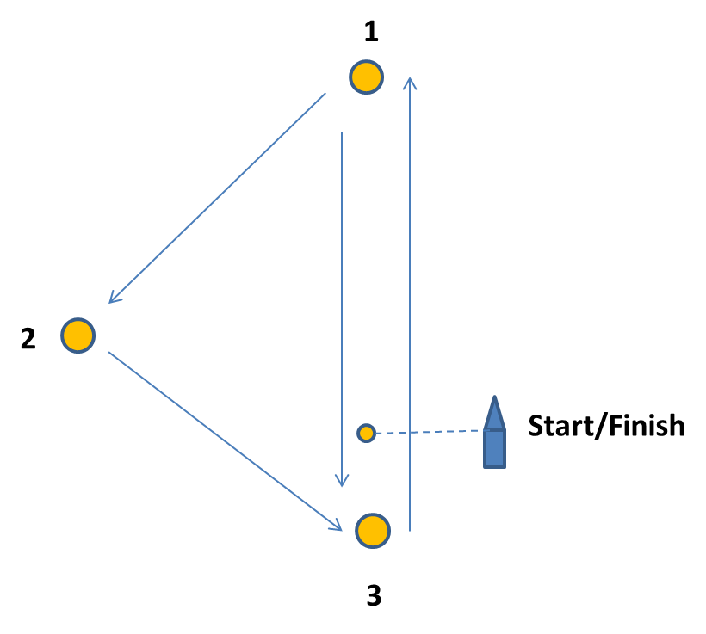
All marks to port
Start, 1, 2, 3, 1, 3, 1, 2, 3, Finish

COURSE B (Windward leeward)
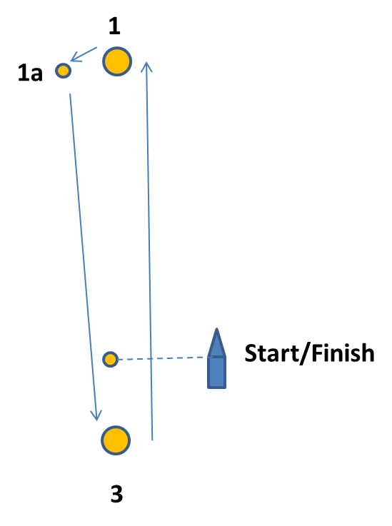
All marks to port
Start, 1, 1A, 3 (number of laps will be displayed on the committee boat)

COURSE C (Trapezoid)
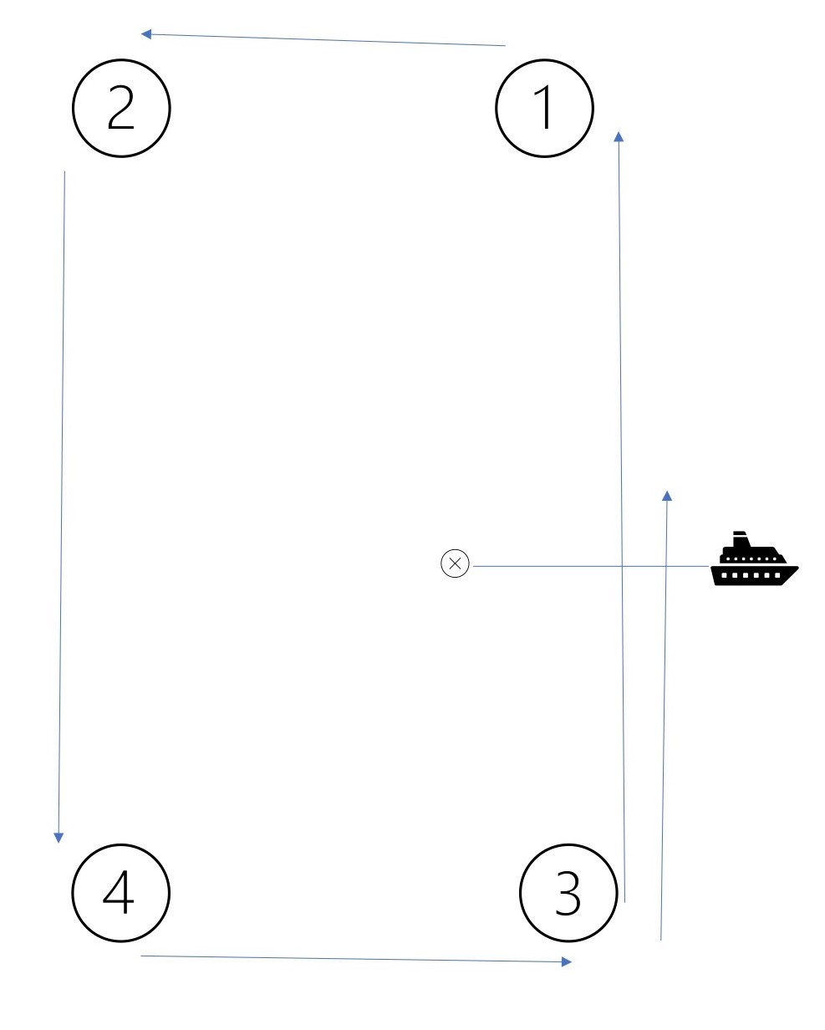
All marks to port
Start, 1, 2, 4, 3 (number of laps will be displayed on the committee boat)

