Medway Yacht Club
L & SE Topper Traveller
Sunday 9th May 2021

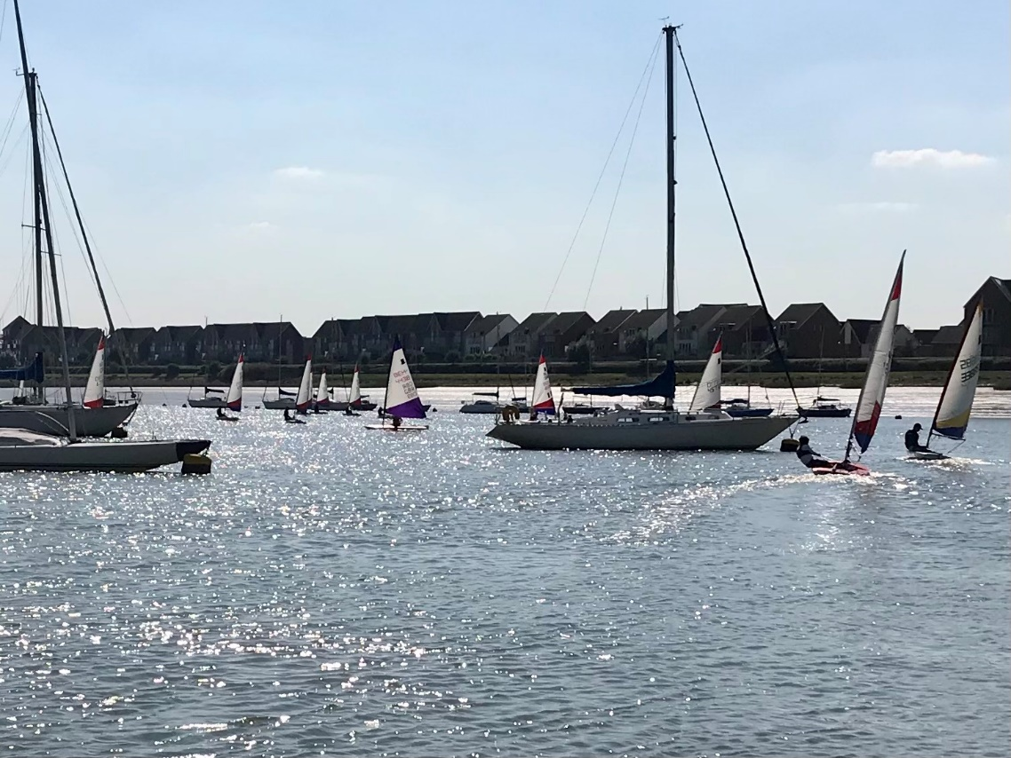
Event Briefing at 10.00hrs
First Warning Signal at 10.55hrs for a 4 Race programme
Entry to be limited to 20 boats- register early
Entry fees - £15
Further details see Notice of Race. Entry through ITCA-GBR website

