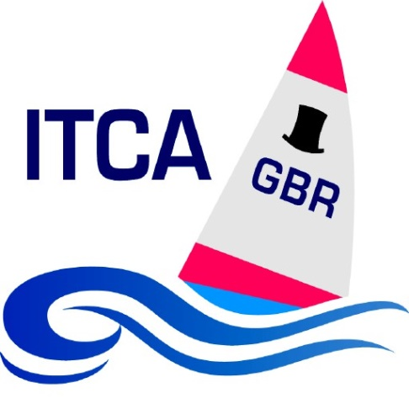
International Topper Class Association (GBR) Notice of Traveller Series
London & South East Area Traveller Series 2020
1 RULES
1.1 The Traveller series will be governed by the Rules as defined in The Racing Rules of Sailing 2017 - 2020.
1.2 Prescriptions of the ITCA (GBR) and any other such instructions determined by the host club for each event will apply.
2 ELIGIBILITY AND ENTRY
2.1 Only current members of a National Topper Class Association can qualify for the series.
2.2 Members of the host club may enter the event at that club.
2.3 Sailors who are not members of a National Topper Class Association may enter one event in the series.
2.4 The entry fee for each event is at the discretion of the host club for that event; please refer to the event notice of race for full details.
2.5 The person and boat stated on the entry form for each event will be the only person that shall compete in that boat at that event.
3 TRAVELLER SERIES EVENTS
3.1 Some events are exclusive to the London & South East Traveller Series and some are shared events. For the purposes of scoring the London & South East Series, all events are considered equal, whether shared or not.
Event 1 14 March Docklands Sailing & Watersports Centre
Event 2 5 April Papercourt Sailing Club
Event 3 12 April Newhaven & Seaford Sailing Club
Event 4 26 April Crawley Mariners Yacht Club
Event 5 16 May Queen Mary Sailing Club *
Event 6 23 May Shoreham Sailing Club
Event 7 7 June Medway Yacht Club
Event 8 21 June Hastings & St Leonards Sailing Club
Event 9 11 July Felpham Sailing Club
Event 10 19 Sept Island Barn Reservoir Sailing Club *
Event 11 17 Oct Bough Beech Sailing Club
Event 12 24 Oct Tamesis Club
Event 13 1 Nov Weir Wood Sailing Club

* These events are shared with the other Regions Traveller series
4 SAILING INSTRUCTIONS
4.1 Sailing Instructions will be published by the host club and be available at the event.
5 SCORING
5.1 The Area Traveller Series will be governed by the Rules as defined in The Racing Rules of Sailing 2017-2020.
5.2 The low points scoring system of Appendix A will apply.
5.3 An event will be deemed to have been “Sailed” when one or more starts have taken place.
5.4 The number of events to count shall be one plus half the number of events “Sailed”, rounded down to the nearest whole number, and subject to a maximum of seven events. This maximum is a variation from normal ITCA (GBR) Traveller series rules.
5.5 For the London & South East Traveller Series, a DNC shall be scored as one more than the largest entry of all London & South East 2020 Traveller series events, whether shared events or otherwise.
6 TRAVELLER SERIES PRIZES
6.1 Prizes for the Traveller series will be awarded for: First Overall Second Overall Third Overall and first female sailor, Other prizes may be awarded for the series at the discretion of the London & South East Topper Traveller Series Administration Team, subject to participation levels and series qualifying criteria being met.

7 DISCLAIMER OF LIABILITY
7.1 Competitors participate in the regatta entirely at their own risk. The organising authority will not accept any liability for material damage or personal injury or death sustained in conjunction with or prior to, during, or after the regatta.
8 RISK STATEMENT
8.1 Rule 4 of the Racing Rules of Sailing states:
“The responsibility for a boat’s decision to participate in a race or continue racing is hers alone.”
Sailing is by its nature an unpredictable sport and therefore inherently involves an element of risk. By taking part in the event each competitor (and their parent(s) or guardian(s) in the case of a competitor under 18 years of age) agrees and acknowledges that:
a. They are aware of the inherent element of risk involved in the sport and accept responsibility for the exposure of themselves, their crew and their boat to such inherent risk whilst taking part in the event;
b. They are responsible for the safety of themselves, their crew, their boat and their other property whether afloat or ashore;
c. They accept responsibility for any injury, damage or loss to the extent caused by their own actions or omission
d. Their boat is in good order, equipped to sail in the event and they are fit to participate;
e. The provision of a race management team, patrol boats and other officials and volunteers by the event organisers does not relieve them of their own responsibilities;
f. The provision of patrol boat cover is limited to such assistance, particularly in extreme weather conditions, as can be practically provided in the circumstances;
g. It is their responsibility to familiarise themselves with any risks specific to this venue or this event drawn to their attention in any rules and information produced for the venue or event and to attend any competitor briefing held for this event.

9 INSURANCE
8.1 Each participating boat shall be insured with valid third-party liability insurance with a minimum cover of £ 3,000,000 per event.
10 MEDIA RIGHTS
10.1 By entering the event competitors and their supporters accept that they may be photographed and/or videoed participating in the event and/or using the event facilities and they consent to the taking and use of such images in any media, in conjunction with their name or not, without compensation and without the approval of the competitor or supporter of such images or any use thereof.
If you do not wish for your image to be published, then this must be noted on the entry form
11 General Data Protection Regulations 2018
Whilst we collect data at every Traveller event as per the entry form, we do not retain these forms for longer than ninety days, unless required by law.
We do need to collect data in respect of Traveller results, this allows us to compile a results listing and series result which we publish on the ITCA website.
There is a consent box on the entry form, which allows you to have your sailors information withheld and we would record the result as “anonymous”
Should you desire that the results information for your sailor be removed, again this can be done and the sailors details will be recorded as “anonymous”
We would like to keep all sailors names, Topper details and results listed on the website as historical data.
We promote the Traveller series by having articles published in local newpapers and various sailing journals together with the clubs hosting the events. This helps us promote the class and also the sailors taking part.
12 FURTHER INFORMATION
9.1 For further information please contact: Graham Evans, ITCA London & South East representative, arearep.southeast@itca-gbr.co.uk
ITCA website : http://www.itca-gbr.co.uk/

