TOPPER SUPER SOUTH TRAVELLER - POOLE

Saturday 5th June and Sunday 6th June 2021
Organising Authority - Poole Yacht Club
Poole Harbour, UK
Notice of Race (NoR) V2 dated 2 June 2021
 | The notation ‘[NP]’ in a rule means that a boat may not protest another boat for breaking that rule. This changes RRS 60.1(a).
1 | RULES
1.1 | The event is governed by the rules as defined in The Racing Rules of Sailing.
1.2 | The Rules of the Topper Class Association, available at https://www.sailing.org/tools/documents/TopperClassRules20190228-[24822].pdf, applies.  This Notice of Race, available at https://gbrtopper.ourclubadmin.com/mini-event.php?event=925, applies.  The Sailing Instructions for this event, available at https://gbrtopper.ourclubadmin.com/mini-event.php?event=925, applies.
1.3 | [NP] COVID Statement By taking part in any of the events covered by this notice of race, each competitor agrees and acknowledges that they are responsible for complying with any regulations in force from time to time in respect of COVID-19 and for complying with the Poole Yacht Club COVID-19 procedures. Competitors and support persons shall comply with any reasonable request from an event official. Failure to comply may be misconduct. Reasonable actions by event officials to implement COVID-19 guidance, protocols or legislation, even if they later prove to have been unnecessary, are not improper actions or omissions.
2 | SAILING INSTRUCTIONS
2.1 | The sailing instructions will be on the official notice board located on the south side of The Poole Yacht Club clubhouse and may be posted online.
3 | COMMUNICATION
3.1 | The online official event WhatsApp communication group is available on https://chat.whatsapp.com/KrzlZvRHcSM35ePa79m7EG.
3.2 | [DP] From the first warning signal until the end of the last race of the day, except in an emergency, a boat shall not make voice or data transmissions and shall not receive voice or data communication that is not available to all boats.
4 | ELIGIBILITY AND ENTRY
4.1 | The event is open to all International Topper class dinghies.
4.2 | There will be separate racing fleets for boats using 5.3 sails and 4.2 sails.
4.3 | Every competitor must be a current member of a National Topper Class Association. Competitors that are not already a member of a National Topper Class Association may join ITCA (GBR) at registration, or pay £20 (or £5 if a member of the host club) to become a temporary member of ITCA (GBR) for the duration of the event.
4.4 | Substitution of competitors will not be allowed. Only the person listed as the competitor on the entry form for a boat shall compete in that boat in the event.
4.5 | Eligible boats may enter and pay by registering online at https://gbrtopper.ourclubadmin.com/mini-event.php?event=925. Entries will close 21:00 on Saturday 29th May 2021
4.6 | To be considered an entry in the event, a boat shall complete all registration requirements and pay all fees.
4.7 | Late entries will be accepted at the sole discretion of the Organising Authority.
4.8 | The following restrictions on the number of boats apply: 60 (total of Topper 4.2s and Topper 5.3s). Priority will be given on a first come basis of correctly completed application and fee paid.
5 | FEES
5.1 | Entry fees are as follows:  Class Entry Fee  Topper 4.2 or 5.3 £45
5.2 | Other fees:  Car parking for visitors will be offsite in Poole Harbour Commissioners Car Park fat a rate of £13 for the weekend plus £5 refundable security deposit for the entry card. Visitors will be shown where to drop off their boat and launch trolley and will then be shown available offsite parking.
6 | CANCELLATION
6.1 | The Organising Authority may cancel the event, cancel classes and reject or cancel entries in its absolute discretion, subject to RRS 76.
6.2 | Should the Organising Authority cancel a class or reject an entry they shall refund the entry fee in full.
6.3 | Should the Organising Authority cancel the event at least 36 hours prior to the scheduled start of race 1 the entry fee will be refunded less a £5 administration charge.
6.4 | Should the Organising Authority cancel the event within 36 hours of the scheduled start of race 1 any refunds will be at the sole discretion of the Organising Authority.
6.5 | 1. Covid-19 refunds –  a. If a competitor needs to cancel due to a requirement to self-isolate or  b. If due to tighter Government Covid-19 restrictions or adverse weather conditions, the event is cancelled then it will be planned to provide a full refund (however this may be less any unrecoverable costs of the Organising Authority).  2. If an entry is cancelled by the participants for any other reason their entry fee will be refunded as follows:  a. Cancellation more than 14 days before the event. Entry fee less £5 admin charge  b. Cancellation more than 7-14 days before the event if place can be resold. Entry fee less £5 admin charge  c. Cancellation within 7 days of the event. No refunds  3. If any sailor is unable to attend a session on the day for any other reason no refund will be available.
7 | ADVERTISING
7.1 | Boats may be required to display advertising chosen and supplied by the organizing authority.
9 | SCHEDULE
9.1 | Registration:  Date From To  Saturday 5th June 2021 08:00 10:00
9.2 | Dates of racing:  Date Topper 5.3 Topper 4.2  5th June 2021 racing racing  6th June 2021 racing racing
9.3 | Number of races:  Class Number Races per day Scheduled Races per day Maximum  Topper 5.3 6 3 4  Topper 4.2 6 3 4
9.4 | The scheduled time of the warning signal for the first race each day is:  Date Warning signal for first race  5th June 2021 Not before 11:25  6th June 2021 Not before 10:25
9.5 | On the last scheduled day of racing no warning signal will be made after 14:25.
10 | EQUIPMENT INSPECTION
10.1 | All boats shall comply with the International Topper class rules. Each boat shall produce or verify the existence of a valid measurement certificate.
10.2 | [DP] A boat or equipment may be inspected at any time for compliance with the class rules and sailing instructions. On the water, a boat can be instructed by a race committee equipment inspector or measurer to proceed immediately to a designated area for inspection.
12 | VENUE
12.1 | NoR Addendum A shows the plan of the event venue.
12.2 | NoR Addendum B shows the location of the racing areas to the west of Brownsea Island and south of the Poole Yacht Club in what is known as the Top Triangle of Poole Harbour.
13 | COURSES
13.1 | The course(s) to be sailed will be as follows: trapezoid inner/outer loop
14 | PENALTY SYSTEM
14.1 | RRS 44.1 shall apply.
15 | SCORING
15.1 | The scoring system in Appendix A of the RRS shall apply.
15.2 | One race is required to be completed to constitute a series.
15.3 | (a) When fewer than 4 races have been completed, a boat’s series score will be the total of her race scores.  (b) When 4 or more races have been completed, a boat’s series score will be the total of her race scores excluding her worst score.
16 | SUPPORT PERSON VESSELS
16.1 | [DP] Support person vessels shall be marked with a coloured flag provided by the Organising Authority.
18 | BERTHING
18.1 | [DP] Boats shall be kept in their assigned places while in the boat park.
21 | DATA PROTECTION
21.1 | Any data you provide will be securely stored and used to run the event.
22 | RISK STATEMENT
22.1 | RRS 3 states: ‘The responsibility for a boat’s decision to participate in a race or to continue to race is hers alone.’ By participating in this event each competitor agrees and acknowledges that sailing is a potentially dangerous activity with inherent risks. These risks include strong winds and rough seas, sudden changes in weather, failure of equipment, boat handling errors, poor seamanship by other boats, loss of balance on an unstable platform and fatigue resulting in increased risk of injury. Inherent in the sport of sailing is the risk of permanent, catastrophic injury or death by drowning, trauma, hypothermia or other causes.
23 | INSURANCE
23.1 | Each participating boat shall be insured with valid third-party liability insurance with a minimum cover of £3,000,000 per incident or the equivalent.
24 | PRIZES
24.1 | Prizes will be awarded to the winner of the event.  Other prizes may be awarded at the discretion of the class or organisers.
25 | END OF NOTICE OF RACE  FURTHER INFORMATION
25.1 | Further information about the Club and the area can be found on the “visitors” page of The Poole Yacht Club website https://www.pooleyc.co.uk/; for further information including to book access for support craft or overnight stays for caravan and camper vans please contact the office at The Poole Yacht Club [01202 672687].

Addendum A
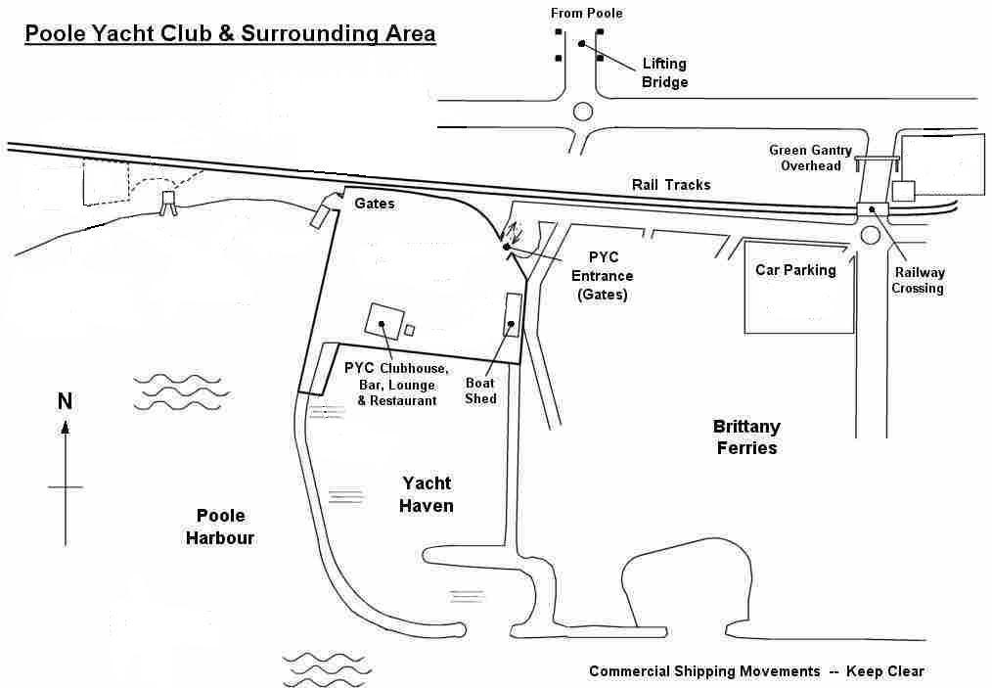

Addendum B – Race Area
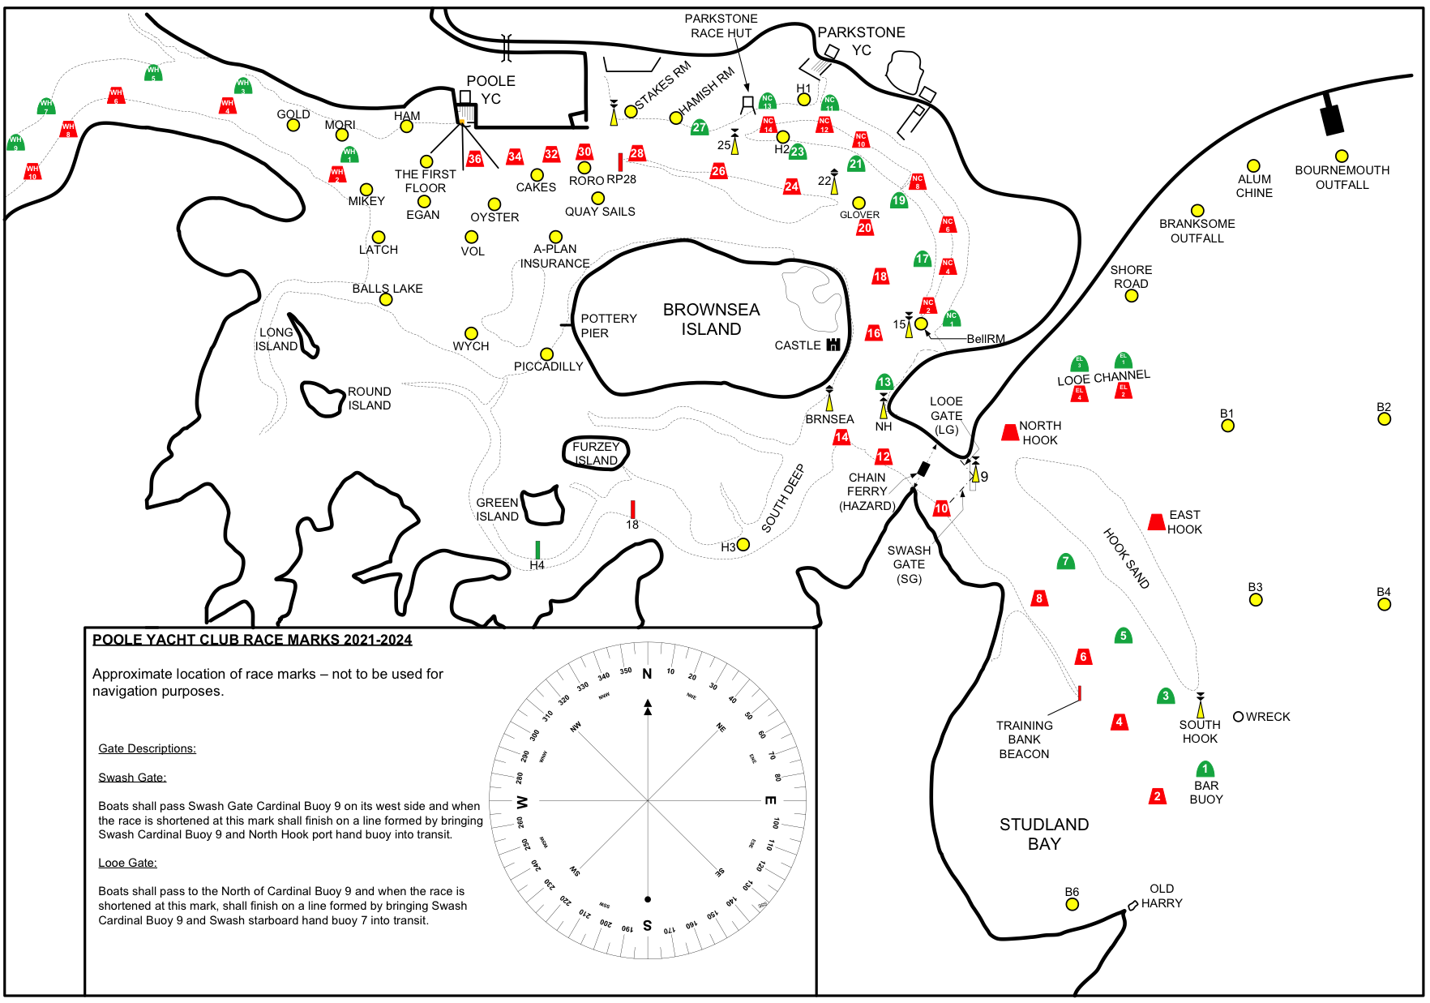
Expected Race Area

