L&SE TOPPER Traveller Open Meeting
Hosted by Crawley Mariners YC
Sunday18thApril2021
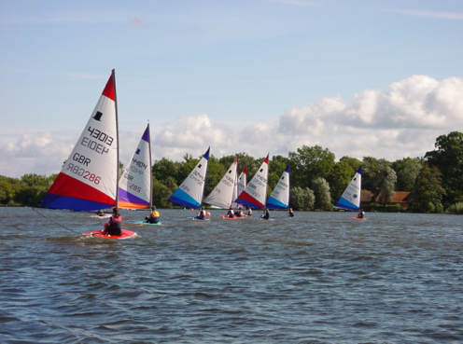
Gates open at 08.15
Briefing 10.00&First Race 11.00
Entry Fee £10
There will be prizes for the main winners, plus additional prizes for those just starting out and/or endeavour. We aim to run 2 races, followed by lunch and 2 races after lunch, subject to wind conditions.

Hedgecourt Lake is quite protected and therefore an ideal venue for those new to Open Meetings. However, due to its restricted size we have to limit numbers to 35. So, if you do intend to come, you are permitted to take part in this Open at your own club without being a member of ITCA, but if you decide to do others you will need to join. It is not expensive and you will get lots of help and of information.

Any CMYC racers wishing to join-in please use the ITCA GBR (International Topper Class Association) website and select the South East Region racing events. Do book in as soon as possible to secure your place.

The entry fee can be paid on the day either by cash or cheque (made payable to CMYC Ltd.) Payment can also be made via Bank Transfer, and if using this method please contact training.cmyc@gmail.com for relevant details. Remember to indicate on the payment it is for the ‘Topper Open’.

You can access the Sailing Instructions here, or via the Policies & Documents section of the Members Area of the CMYC website.

Go on, dig out that Topper and come along!
(Dogs on leads are welcome)

Refreshments:

Due to current Covid restrictions we will only be offering a limited
‘take away’ service of soup and sandwiches.

Hot and cold drinks available free of charge during the day.
Please bring your own refillable mug for your own use during the day!

Contact: Diana – training.cmyc@gmail.com

