Event | Midlands ITCA Traveller R4 – Draycote SC (22nd May 2021)
Championship Number |  | Sail Number
Boat Class | Topper
Home Club
Sailor’s Name
Home address
Contact Phone No (emergency)
Date of Birth
Email address
Do you have any medical conditions that may affect your ability to take part? | Yes/ No  (If yes add details below E.g. Epilepsy, asthma, diabetic etc)
NOTE: All boats must be covered by a minimum of £3 million third party insurance. Personal buoyancy must be worn at all times whilst on the water. Participation in the event is on the understanding that the risks associated with algae or other contamination are accepted and the organizers of the Open Event will not be liable for ill effects or personal injury arising. I agree to be bound by the Sailing Instructions for the event and the Racing Rules of Sailing.
Signed  (competitor) |  |  | Name:  Date:
Declaration of Parent or Guardian of participants under 18: Under law this competitor is my dependent. I accept the statement of liability in the Notice of Race and Sailing Instructions and agree to the statements contained within these. During the event the boat sailed by my dependent will have a valid third party insurance of at least £3 million. I confirm that my dependent is competent to take part and that I will remain responsible throughout the event. To satisfy local Sailing Waters Biosecurity rules I confirm that our boat has been cleaned and fully dried before being launched at the hosting Sailing Club.
Signed  (parent or guardian) |  |  | Name:  Date:

COVID:
If you, or anyone in your household, is showing any signs of COVID symptoms; you must not attend the event.

- You must comply with latest COVID Government/RYA Guidelines
- You must comply with any further guideline/rules imposed by the host club.
- Respect social distancing
- Wash your hands
- Know your sailing limits and do not put yourself or others at risk
- Ensure your boat is fully prepared and fit to sail before going out on the water
- Be mindful of others on the water, the beach or around the boat-park
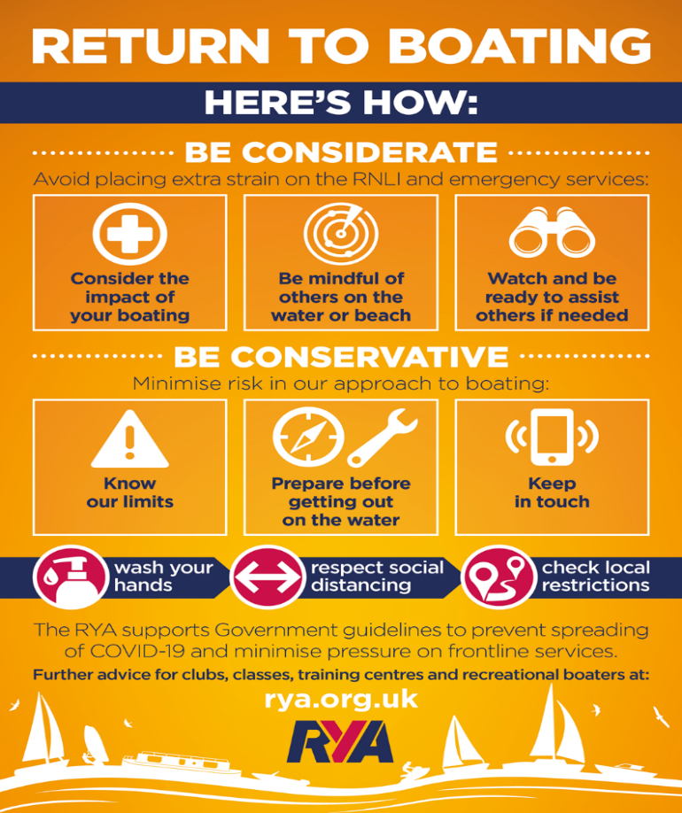
To remain compliant within Government requirements to collate test and trace visitor information, please provide the following details for every person attending with the sailor:
Name | Address. (Write as above if same as sailor) | Contact number

