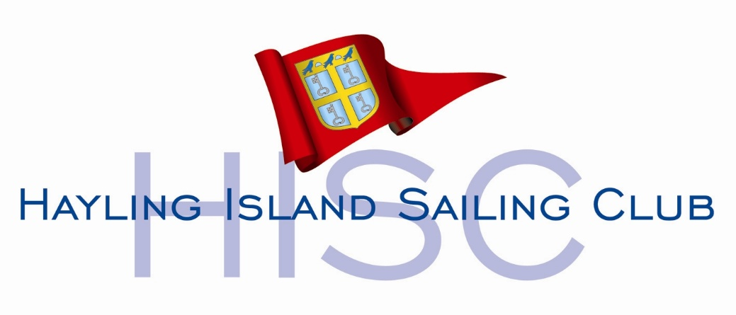

ITCA COASTAL CHAMPIONSHIP

NS4

9th – 10th MAY 2026

EVENT INFORMATION

Full information regarding opening times
accommodation, food and drink etc. can be found at
www.hisc.co.uk

Hayling Island Sailing club
Sandy Point
Hayling Island
PO11 9SL
02392 463768
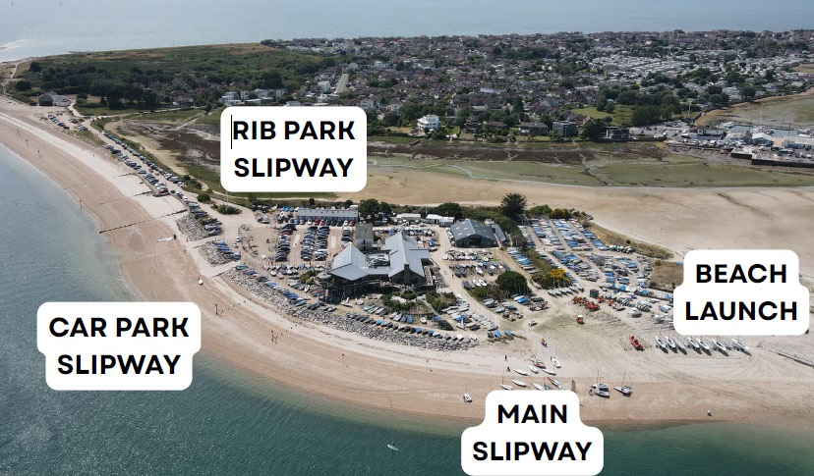

Transit routes to the racing areas are indicated in the diagram. The safety teams will provide escorts to the competitorstrtrrtrtrtr of the best routes subject to tide and weather.

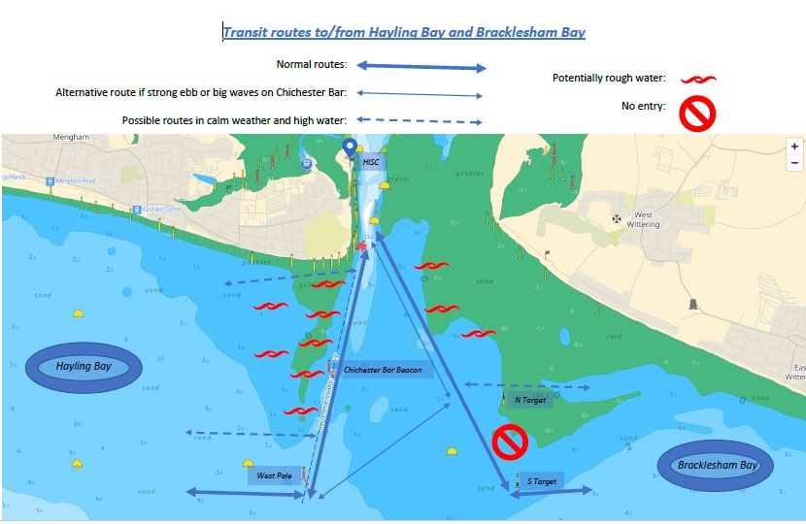

Welfare

Each main committee vessel has toilet facilities that can be accessed by all on the water personnel, both sailors and volunteers. The committee vessels have mixed crews with regard to safeguarding arrangements.

Medical Casualties

The event has appointed an on-site Medic who in liaison with the Event Safety Officer, will co-ordinate medical responses for the event.

The Event Medic is provided by Hayling Medical Services.

The role is to provide medical cover to all Volunteers, and Competitors.

The Event Medic and ESO will be made aware of other event personnel who have appropriate First Aid training.

Whilst the Medic is on site, decisions to call an Ambulance should be taken by the Medic. If for any reason an Ambulance is called from the water, the Medic and ESO must be informed at the same time.

First Aid

If a person on the water requires ‘First Aid’ an initial assessment can be made by the Safety Boat. Contact should be made with the Medic who will decide and may direct them to be taken to the Emergency Landing point, as indicated on the site plan.

External Emergency Ambulance Service

Calls to external emergency services should only be made by ESO or the Event Medic.
An emergency call can be made by personnel on the water, if they deem that life is in grave and imminent danger and a time critical response is required and after consulting with the on site Medic. They should inform the ESO of the actions taken as soon as possible. Casualties will be landed at the Emergency Landing Point.

The First Aid Room is located on the Ground Floor.

Medical Centres

To avoid unnecessary pressure on the NHS, event personnel should be seen initially by the Event Medic who will direct them towards the most appropriate medical centre if required.

The main hospital Emergency Department is at:

Queen Alexander Hospital
Cosham
Portsmouth
PO6 3LY
023 9228 6000
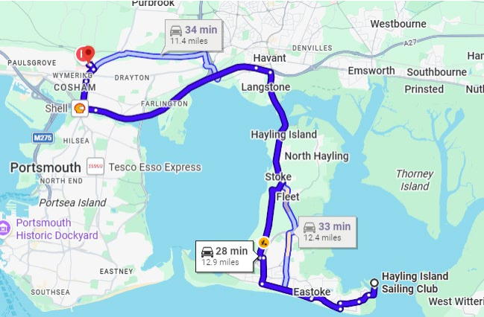

Urgent Treatment Centre

An urgent treatment centre is also available with opening times of 08.00 to 20.00
Practice Plus Group Urgent Treatment Centre,
Milton Road
Milton Road
Milton
Portsmouth
Hampshire PO3 6DW
