2025 Rooster Southern Traveller Event 8 – Warsash

Sunday 14th Date 2025

Warsash - LW – 09:43 / HW - 16:22 (BST)

Sailing Instructions – v2

1 RULES

Racing will take place under The Racing Rules, the Class Rules, the Notice of Race and these Sailing Instructions (SIs). In the event of a conflict these SIs shall apply.

RRS Appendix T (Arbitration) applies.

Competitors should note that Warsash Sailing Club implements the RYA Racing Charter and that they will be required to undertake to sail in compliance with the RYA Charter which can be found at the front of the RYA rule book.

The Racing rules of Sailing will be changed as follows:

Rule 40 shall apply at all times when afloat.

Rule A3 changed so, at the Race Committee’s discretion and after the first boat has finished, boats may be award points according to their observed position on the course. See SI 14.2

NOTICES TO COMPETITORS

Notices to competitors will be posted on the official event WhatsApp group.

There will be competitor briefings at 0830 on Sunday in the Main Hall in Shore House.

CHANGES TO SAILING INSTRUCTIONS

Any change to the sailing instructions will be posted on the official notice board before the briefing on the day it will take effect, except that any change to the schedule of races will be posted by 2000 on the day before it will take effect.

SIGNALS MADE ASHORE

Signals made ashore will be displayed on the Shore House Flag Staff.

When Flag AP is displayed ashore, ‘1 minute’ is replaced by ‘not less than 60 minutes’ in the race signal AP.

SCHEDULE OF RACES

The scheduled time of the warning signal for the first race on Sunday is 0930. It is intended to sail 4 races.

No start sequence will commence after 1530 except following a general recall of that race.

CLASS FLAGS

The class flag for the 5.3 Fleet will be T Flag and the 4.2 Fleet D Flag

RACING AREAS

The race area will be within Southampton Water/The Solent, in the vicinity of Coronation Buoy. These buoys are shown on the chart in Appendix C below.

Competitors will be escorted to and from the Race Area.

Competitors are reminded that it is approximately 2 miles to the race area and that racing will start promptly.

THE COURSE

The diagrams in Appendix A & B show the courses for the 4.2 & 5.3 fleets, including the approximate angles between legs, the order in which marks are to be passed, and the side on which each mark is to be left.

The number of upwind legs will be displayed on the Committee Boat prior to the commencement of each start sequence.

MARKS

Marks 1, 2,3, 4 and 5 will be Black or Orange inflatable buoys.

The Outer Distance Starting Mark will be a Committee Boat or a Dan Buoy flying an Orange Flag.

The Outer Distance Finish Mark will be a small orange inflatable buoy.

The Race Committee may use marks of a different size/colour and the start and finish marks may both be in place at the same time.

THE START

Races will be started by using Rule 26 (5, 4, 1 Go).

The Starting Line will be between the staff displaying an orange flag on the Committee Boat and the port-end Start Mark.

There will be a separate start for the 4.2 fleet. The intended start order will be the 5.3 fleet followed by the 4.2 fleet.

If there is a general recall for the 5.3 fleet it is intended to restart them before the 4.2 fleet.

A boat starting later than 4 minutes after her starting signal will be scored Did Not Start. This changes RRS A4 & A5.

CHANGE OF THE NEXT LEG OF THE COURSE

To change the next leg of the course, the Race Committee will move the original Mark (or the Finishing Line) to a new position.

Changes of length of the leg or of less than 10 degrees will not be signalled. This Changes RRS 33.

When Flag ‘F’ is displayed with repeated sound signals at Mark 1 boats shall proceed to the finish rounding marks 2, 3 and 4 to port. When it is displayed at Mark 3 boats shall proceed to the finish rounding mark 4 to port.

THE FINISH

The Finishing Line will be between the staff displaying a blue flag on the Committee boat and the finish mark.

TIME LIMITS

The intended duration of each race is 35 to 40 minutes.

To expedite the series, and at the Race Committee’s discretion, boats failing to finish within 10 or more minutes of the first boat may be awarded points according to their observed position on the course. The display of Flag ‘W’ with 5 sound signals will indicate that this SI applies. This changes Rule A.4.1.

COMMITTEE BOAT IDENTIFICATION

The Committee Boat will be “Lobster” and will display a Warsash committee flag and club burgee.

PROTESTS AND REQUESTS FOR REDRESS

A boat that intends to protest shall inform the Committee Boat immediately after finishing the race in which the incident occurred.

RRS Appendix T (Arbitration) applies.

Protest forms are available at the Race Office and shall be delivered there. Protests shall be delivered within the protest time limit.

The protest time limit is 30 minutes after the last boat in the class returns ashore.

Notices will be posted within 30 minutes of the protest time limit to inform competitors of hearings in which they are parties or named as witnesses. Hearings will be held at the earliest opportunity.

SCORING

Points will be accrued to the helm named on the entry form and not to the boat entered.

2 races are required to be completed to constitute a series. Discards will be applied as follows:

a) When fewer than 4 races have been completed, a competitor’s series score will be the total of her race scores.

b) When from 4 to 6 races have been completed, a competitor’s score will be the total of her race scores excluding her worst score.

SAFETY REGULATIONS

Competing boats shall not go afloat until released by the Beachmaster.

[NP] Boats shall ‘tally out’ immediately before launching and ‘tally in’ immediately on returning ashore. Failure to comply with this SI will result in a 5-point penalty in the race closest to the infringement, other boats will not be rescored. A boat will not be scored worse that a disqualified boat because of this penalty. This changes RRS 63.1 and A5.

The Tally Board will be located adjacent to the Shore House Club House Garden. Individual Tally Numbers will be issued at registration. The Tally board will close 15 minutes after the last boat returns ashore.

[NP] A boat that retires from a race shall notify the Race Committee as soon as possible and shall not leave the Race Area without the permission of the Race Committee.

Where the Race Committee considers that a boat or competitor is in difficulty it may instruct the boat or competitor to accept outside help, retire or sail ashore.

Replacement of Crew or Equipment

A boat or equipment may be inspected at any time for compliance with the class rules.

Trash Disposal

Boats shall not drop trash in the dinghy park or afloat RRS 47.

SUPPORT BOATS AND INSTRUCTION

Support Boats are only allowed with the prior approval of Warsash Sailing Club and drivers may be asked to show competence in driving such a boat of at least RYA PB2. Support Boats, if allowed, shall have VHF radio communication with Warsash Sailing Club and the Committee Boat and shall be identified at registration.

Unless agreed or instructed by the Race Committee, team leaders, coaches and other support personnel shall stay outside area where boats are racing from the time of a preparatory signal until all boats have finished or the Race Committee signals a postponement, general recall or abandonment.

All support boats are required to comply with RRS 37.

RADIO COMMUNICATION

A boat shall neither make radio transmissions while racing nor receive radio communications not available to all boats. This restriction also applies to mobile telephones.

PRIZES

The event prize giving will be held as soon as possible after racing on the final day. Prizes will be awarded for the first three boats in each class. Other prizes may be awarded.

Rights to use Name and Likeness

By participating in this event, competitors automatically grant to the organising authority and the event sponsors the right, in perpetuity, to make use and show, at their discretion, any photography, audio and video recording, and other reproductions of them made at the venue or on the water from the time of their arrival at the venue, until their departure, without compensation.

Appendix A – Topper 5.3 Course

The Number of laps will be displayed from the committee boat. If the number of laps displayed is ‘1’ then that will apply to both fleets.

Using the diagram below, the Course will be:

For a single upwind race  Start Line  1 (port)  2 (port)  3 (port)  4 (port)  Finish Line | For a 2 upwind race  Start Line  1 (port)  2 (port)  3 (port)  2 (port)  3 (port)  4 (port)  Finish Line | For a 3 upwind race  Start Line  1 (port)  2 (port)  3 (port)  2 (port)  3 (port)  2 (port)  3 (port)  4 (port)  Finish Line

NOTE: The final upwind to the Committee Boat is excluded from the lap counting

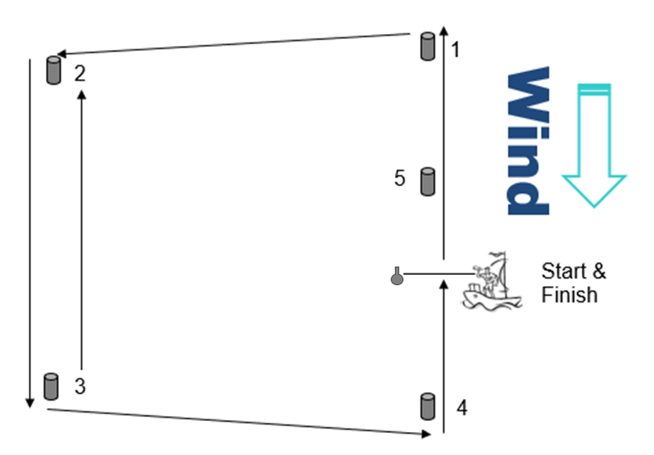
Appendix B – Topper 4.2 Course

The Number of laps will be displayed from the committee boat. If the number of laps displayed is ‘1’ then that will apply to both fleets.

Using the diagram below, the Course will be:

For a single upwind race  Start Line  1 (port)  2 (port)  3 (port)  4 (port)  Finish Line | For a 2 upwind race  Start Line  1 (port)  5(port)  1 (port)  2 (port)  3 (port)  4 (port)  Finish Line | For a 3 upwind race  Start Line  1 (port)  5 (port)  1 (port)  5 (port)  1 (port)  2 (port)  3 (port)  4 (port)  Finish Line

NOTE: The final upwind to the Committee Boat is excluded from the lap counting

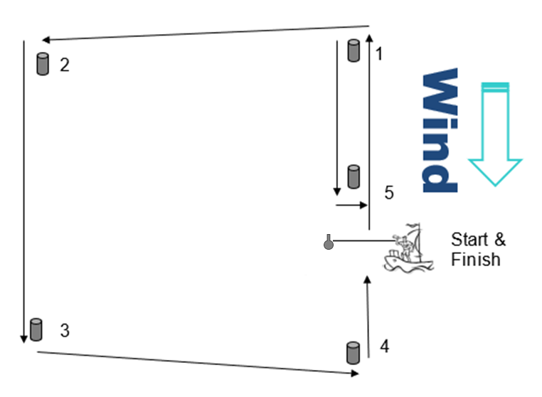

Appendix C – Racing Areas

