Topper 2025 Rooster Southern Traveller Event 8

Organising authority

WARSASH SAILING CLUB (WSC)

In conjunction with

ITCA Southern Topper 5.3 & 4.2

Sunday the 14th September 2025
Warsash, United Kingdom

NOTICE OF RACE

The notation ‘[NP]’ in a rule means that a boat may not protest another boat for breaking that rule. This changes RRS 60.1. The notation ‘[DP]’ in a rule of the NOR or SI means that the penalty for breaching the rule is at the discretion of the protest committee and may be less than disqualification.

1 RULES
1.1 The event is governed by the rules as defined in The Racing Rules of Sailing (RRS).
1.2 RRS Appendix T applies.
1.3 [NP] Warsash Sailing Club implements the RYA Racing Charter available at https://www.rya.org.uk/racing/rules/racing-charter. Competitors shall undertake to sail in compliance with the charters.
1.3.1 The racing rules will be changed as follows:
i RRS 32 changed to allow a race to be shortened at the committee boat on station at the finish.
ii RRS 35 changed to score boats finishing outside the time limit in their observed position on the course.
iii RRS 40 changed so that personal flotation devices must be worn at all times whilst afloat.
The changes will appear in full in the Sailing Instructions and event appendices. These may also change the racing rules.
1.4 [DP] Entrants and authorised guests are temporary members of WSC during the period of the event and shall, always, comply with the Club rules and bylaws. Failure to observe the rules may result in exclusion from WSC premises.
1.5 RRS 40.1 always applies while afloat.

2 SAILING INSTRUCTIONS
2.1 The sailing instructions will be published on the Warsash Sailing Club website and the ITCA website by 17:00 on Wednesday 10th September.

3 COMMUNICATION
3.1 Official event communications will be via the event WhatsApp group.
3.2 [DP] While racing (from the first warning signal until the end of the last race of the day), except in an emergency, a boat shall not make voice or data transmissions and shall not receive voice or data communication that is not available to all boats.
3.3 Competitors should note that it is anticipated that all communication for this event will be online and that the WSC Wi-Fi system may not be accessible. Competitors are advised that they may wish to have a device which can connect to the internet via an alternative means.

4 ELIGIBILITY AND ENTRY
4.1 The regatta is open to all Topper 4.2 & 5.3 helms who are members of ITCA GBR. Competitors may be required to show evidence of membership of their affiliated organisation.
4.2 Eligible boats shall enter by completing the online entry form accessed via the ITCA Website (https://gbrtopper.ourclubadmin.com/event/1581) paying the entry fee of and completing registration by midnight on Wednesday 10th September.
4.3 No late entries will be accepted.
4.4 Parent/Guardian Declarations: All helms and crews under 18 years of age during the event shall submit signed Parent/Guardian Declarations on-line as part of the entry process and submit details of the parent acting in charge of a child who shall be present at WSC at all times during the event.
4.5 Medical forms and sailor declarations included as part of the on-line entry are required to be completed for all competitors.

5 FEES
5.1 The Entry Fees are £30 / £25 as outlined below and shall be paid via the online payment system.
5.2 Entry fees are as follows:

 | Fee
ITCA Member | £30
ITCA and Warsash SC Member | £25

6 IDENTIFICATION & ADVERTISING
6.1 [NP] [DP] When provided by the Organising Authority, boats shall display bow numbers and/or advertising.

7 EVENT SERIES
7.1 The regatta will consist of a single series.
7.2 The regatta may form part of a further series, details of which can be found on the Class Association website.

8 SCHEDULE
8.1 There will be no in-person competitor registration. All competitors should join the event WhatsApp group as detailed in the Sailing Instructions. Support boat crews are required to register in Shore House prior to racing on Sunday 14th September.
8.2 Competitor Briefing: There will be a briefing by the Race Officer at 1000 on Sunday 14th September 2025 at Shore House Garden/Main Hall as the weather dictates. Any relevant notices will be posted on the event Notice Board as defined in the Sailing Instructions
8.3 Format of Racing: It is intended to run 4 races on Sunday 14th September; this may be varied:

Day | First Warning Signal | Intended no. of races
Sunday 14th 2025 | 12:00 hrs | 4 races back-to-back

8.4 On the last scheduled day of racing no warning signal will be made after 15:30.

9 EQUIPMENT INSPECTION
9.1 A boat shall produce a valid measurement certificate if requested by the Class association. This may be in electronic format.
9.2 Towline: each boat shall carry a floating towline of at least 8mm diameter and 10 metres length. This must be accessible without breaching the integral buoyancy of the dinghy and must not have any attachments such as shackles or knots.
9.3. [DP] Boats, sails and equipment may be inspected for class rules compliance prior to or during or after racing.

10 VENUE
10.1 The venue will be Warsash Sailing Club, Shore Road, Warsash SO31 9FS.
10.2 NoR Addendum 1 shows the plan of the event venue.
10.3 NoR Addendum 2 shows the location of the racing areas.
10.4 The race area will be within Southampton Water/The Solent up to 2 miles from WSC in the vicinity of Solent Breezes to the East of the North channel. Boats are not expected to return ashore between races.

11 COURSES
11.1 The Course(s) to be sailed will be detailed in the SIs.

12 PENALTY SYSTEM
12.1 The penalty system will be described in the SIs.
12.2 RRS Appendix P, Special Procedures for Rule 42, will apply as described in the SI’s.

13 SCORING
13.1 One race is required to be completed to constitute a series.
13.2 (a) When fewer than 4 races have been completed a boat’s series score shall be the total of her race scores.
(b) When 4 or more races have been completed, a boats series score will be the total of her race score excluding her worst score.

14 SUPPORT PERSON VESSELS
14.1 Support person vessels will be allowed and will be expected to act as part of the safety fleet if requested to do so by the Race Committee.
14.2 Official, patrol and support person vessels must be registered with WSC prior to the start of the first race and may be required to be marked with an appropriate coloured flag and shall comply with instructions from the event safety officer.
14.3 [DP] Team leaders, coaches and other support personnel including relatives of competitors who are not official, patrol or support person vessels shall not be in the racing area, nor shall they communicate with any competitors, from the time of the preparatory signal for the first race until the last boat returns to shore. The penalty for failing to comply with this requirement will be at the discretion of the protest committee and may be less than disqualification for all boats associated with the support personnel who do so.
a) For the purposes of this rule, the racing area shall be defined as not less than 300m from any boat that is racing, and this shall specifically include an area not less than 200m immediately to leeward of the finish line for any race.
b) For events that are held in restricted waters where the requirements in 14.3 a) are unable to be met, the Race Officer may designate a specific area for team leaders, coaches, or support boats
14.4 Competitors will not be able to place food, drink, and spares on any support vessels.

15 BERTHING
15.1 [DP] Boats shall be kept at the Club dinghy park for the duration of the regatta unless instructed otherwise.

16 DISTINGUISHING NUMBERS
16.1 Under exceptional circumstances, the Race Committee may permit a boat to use sails carrying a distinguishing number other than that required by RRS 77 and RRS Appendix G. Such permission is only valid if sought in writing before proceeding afloat.

17 DATA PROTECTION
17.1 PRIVACY STATEMENT The personal information you provide to the organising authority will be used to facilitate your participation in the event. If you have agreed to be bound by the Racing Rules of Sailing and the other rules that govern the event (the rules), the legal basis for processing that personal information is contract. If you are not bound by the rules, the legal basis for processing that personal information is legitimate interest. Your personal information will be stored and used in accordance with the Warsash Sailing Club’s privacy policy. When required by the rules, personal information may be shared with the RYA and/or World Sailing. The results of the event and the outcome of any hearing or appeal may be published.

18 RIGHT TO USE NAMES AND LIKENESS
18.1 Competitors automatically grant to Warsash Sailing Club, the Class Association, and their sponsors without payment the right in perpetuity to make, use and show any motion pictures, still pictures and live, taped, or filmed television of or relating to the event.

19 RISK STATEMENT
19.1 Rule 3 of the Racing Rules of Sailing states: ‘The responsibility for a boat's decision to participate in a race or to continue racing is hers alone.’
Sailing is by its nature an unpredictable sport and therefore inherently involves an element of risk. By taking part in the event, each competitor agrees and acknowledges that:
(a) They are aware of the inherent element of risk involved in the sport and accept responsibility for the exposure of themselves, their crew and their boat to such inherent risk whilst taking part in the event;
(b) They are responsible for the safety of themselves, their crew, their boat and their other property whether afloat or ashore;
(c) They accept responsibility for any injury, damage or loss to the extent caused by their own actions or omissions;
(d) Their boat is in good order, equipped to sail in the event and they are fit to participate;
(e) The provision of a race management team, patrol boats and other officials and volunteers by the event organizer does not relieve them of their own responsibilities;
(f) The provision of patrol boat cover is limited to such assistance, particularly in extreme weather conditions, as can be practically provided in the circumstances;
(g) It is their responsibility to familiarise themselves with any risks specific to this venue or this event drawn to their attention in any rules and information produced for the venue or event and to attend any safety briefing held for the event: In particular:
• Tidal conditions which are complex with fast tidal flows in the river and shallows along the river and north shore at mid and low water.
• The area is used by a wide variety of craft, including large commercial vessels restricted in their ability to manoeuvre using the main Southampton Water shipping channel.
• In the river leisure craft are constrained to a narrow channel and do not always anticipate the manoeuvres of dinghies whether sailing in the river or around launching and recovery.
• The Convention on the International Regulations for Preventing Collisions at Sea (COLREG) 1972 and local byelaws apply to all craft including dinghies.

20 INSURANCE
20.1 Each participating boat shall be insured with valid third-party liability insurance with a minimum cover of £3,000,000 per incident or the equivalent.

21 PRIZES
21.1 Prizes will be awarded depending on entry numbers.

22 FURTHER INFORMATION
For further information please contact either

Admin, Warsash Sailing Club, Shore Road, Warsash, Southampton, SO31 9FS.
Phone 01489 583575 (0930 – 1500 Weekdays).
Email: admin@warsashsc.org.uk.
Web: www.warsashsc.org.uk

Addendum 1 - Site Plan

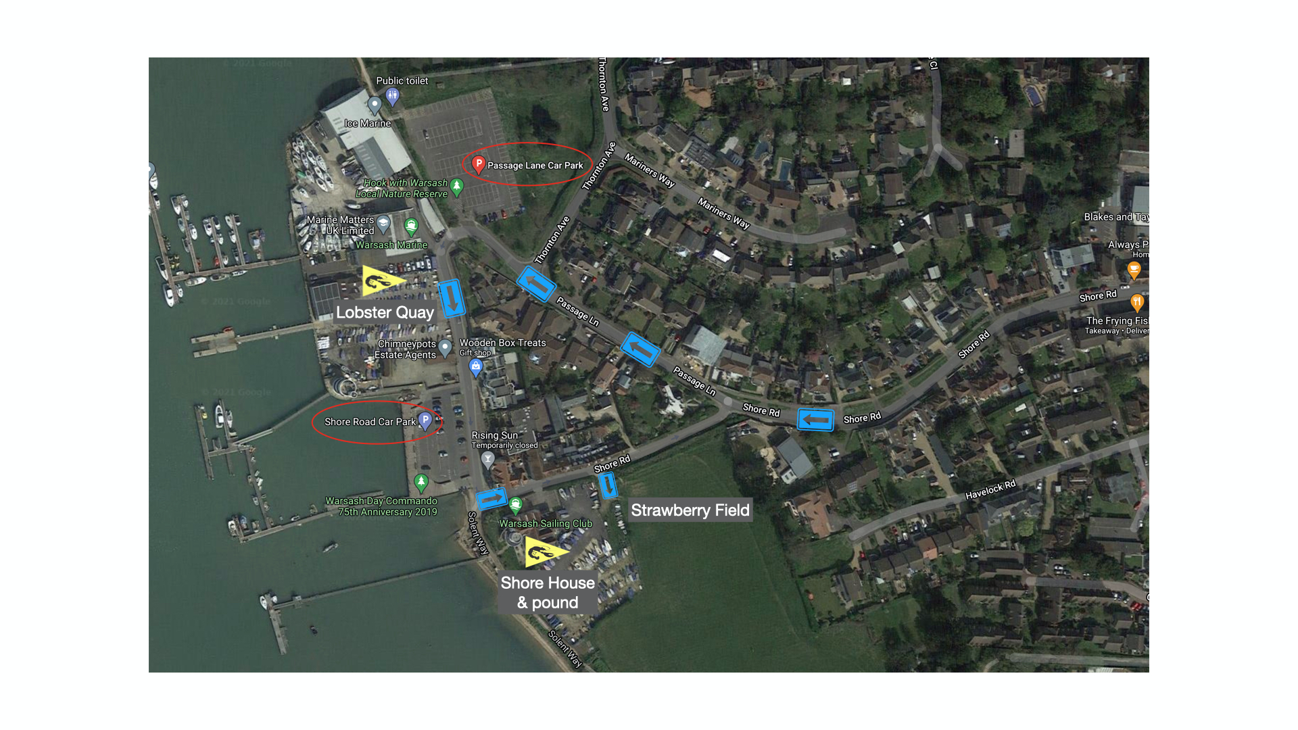

Addendum 2 - Racing Area
The main race area is in the vicinity of Solent Breezes, or Cat Head as an alternative.

