
EVENT & DATE: Topper East Coaching and Open.
March 29th/30th 2025
Pre-Event information
RO: Eric Joyce
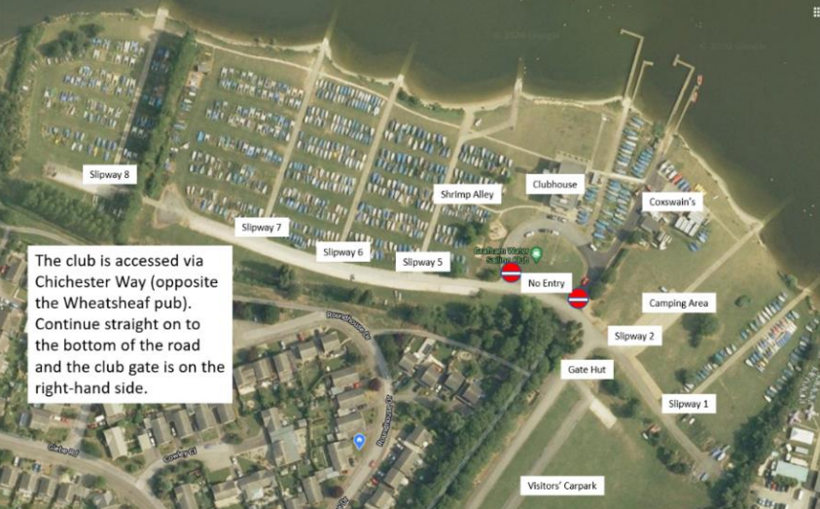
Car & Trailer Parking:
The grass is possibly too wet for parking. Please follow the car parking marshall’s guidance. If you are asked not to use the grass areas it is essential that you don’t! Apart from the gouges in the surface, if you get bogged down you we cannot use the tractor to pull you out. Campers should go directly to their booked space and can launch from slipways 1 & 2. Everybody else should walk their boats to the launch areas of slipways 5,6 & 7.
Alternatively, park on the hard section alongside the road above the dinghy park, leaving car and trailer perpendicular to the road please. Boats should be wheeled from there to the launching areas. We suggest using slipways 5, 6 and 7. On Sunday please park as you do on Saturday as we shall also be busy with club members.
Event communications:
The Official Notice Board is online, so please bring mobile device. The Notice Board can be accessed via https://www.grafham.org/online-noticeboard.html. Email for use during the event will be office@grafham.org
Wash down:
Boats must be washed down before leaving the Club to comply with non-native species guidance. There will be jet washers in shrimp alley, and a hose by slipway 2.
Results:
Will be published online as soon as possible after the completion of racing on the GWSC web site.
Prize giving:
Will be in the upstairs lounge at 1530 or as soon as practical thereafter.
Catering:
The café on the ground floor of the Clubhouse will be open.
Safety & Security:
Please do not walk through fenced off areas: they are fenced off for your safety.
Take particular care of the coxswains’ slipway (East side of the Clubhouse in front of the coxswains’ shed) as there
are regular tractor movements on this slipway.
The fire exits from the Clubhouse are marked – the fire muster point is on the grass of the roundabout on the landside of the Clubhouse.
Please do not leave kit bags in the changing rooms, we cannot guarantee the safety of items left in there. Club members will also need space in which to change particularly on Sunday. There are lockers (green) in the café area which take a £1 coin
Sailing
Competitor Briefing: There will be a short competitor briefing at 1000 outside the café.
Please make sure that you have read the SI as it is not the intention to discuss them at the briefing.
Race Area: Will be confirmed on the Online Notice Board and competitors' briefing.
Starting: It is intended that we will use “P” (Papa) as the preparatory flag, at least initially, for the first attempted start in each race. If there are frequent General Recalls or if we are under time pressure we will probably use the Black flag throughout.
The start line will be set square to the measured mean wind direction…after that we are at the mercy of the usual random wind shifts. Races will be postponed if there is excessive perceived bias.
Finishing: Only the first 3 boats will be given a finishing sound signal. If you are finishing in a crowd of boats, do note the sail numbers around you in case we cannot see your number. Note that boats within a fleet may sail different numbers of laps.
Trash: Carry your own personal supply of food, drink and kit, you will not be able to deposit your dry bags nor trash in the safety boats.
First race of the day: Our aim is to start on time: please allow adequate time for launching; take into account the number of competitors which includes club members trying to launch and plan accordingly.
Launching: Please do not leave your trolley so that it blocks the slipway. There are mooring buoys next to the slipways that can be used to secure to whilst moving your trolley, or alternatively, buddy up to assist each other.

